|  |  |  |
| --- | --- | --- |
|  |  |  |
|  |  |  |
|  |  |  |
|  |
|  |
| **Full Documentation for Dern-Support**  **Moayad Hamdan** |
|  | **To: Dern-Support** |  |
|  |  |  |
|  |  |  |

Contents

Project Overview: Dern-Support 6

Objective: 6

Key Features: 6

Technical Stack: 6

Expected Outcomes: 6

Statement of the Problem: 7

Task 1a: Project Planning and Analysis 8

1) Proposal for Full Stack Solution Before Refinement 8

Business Context and Problem Summary 8

Description of the Proposed Solution 8

Functional and Non-Functional Requirements 10

Key Performance Indicators (KPIs) 11

Risks and Implications of the Proposed Solution 12

Proposal Review and Approval Process (Client approval documentation after feed back  ( Before and After )) 13

2) Proposal for Full Stack Solution After Refinement 27

Business Context and Problem Summary 27

Description of the Proposed Solution 27

Functional and Non-Functional Requirements 30

Key Performance Indicators (KPIs) 30

Risks and Implications of the Proposed Solution 31

Task 1b: Design and Documentation 32

Software Design Document 32

1. Functional and Non-Functional Requirements Specifications 32

2. Algorithm Design Documentation 33

3. Visual Design Documentation 37

4. Data Requirements Design 41

5. Accessibility and Inclusivity Considerations 43

6. Reused/Refactored Components 45

Review and Feedback Record 49

Justification of design decisions and update design for Flow Chart 55

Justification of design decisions and update design for Wireframes 66

Task 1c: Development and Testing 69

Testing, Feedback Analysis, and Evaluation the Software Solution 69

1) Development Process and Tools Used 69

2) Test Plans 70

3) Issues Encountered and Resolutions 71

Live Test Cases and Results 72

4) Documenting Problems and Errors 88

Feedback Analysis and Refinement 96

Evaluation of the Solution 98

Conclusion 107

Summary of the Project’s Achievements: 107

Lessons Learned: 108

Recommendations for Future Improvements: 108

**Table of Figures**

Figure 1me to client 1 15

Figure 2 me to client 2 17

Figure 3 client to me 1 19

Figure 4 client to me 2 21

Figure 5 me to client 3 23

Figure 6 me to client 4 25

Figure 7 client to me 3 27

Figure 8 Functional Requirements 33

Figure 9 Non-Functional Requirements 33

Figure 10 Flow Chart img 1 35

Figure 11 Flow Chart img 2 36

Figure 12 Home Wireframes 38

Figure 13 Login Wireframes 38

Figure 14 Register Wireframes 39

Figure 15 Request Wireframes 39

Figure 16 job Wireframes 40

Figure 17 knowledge base Wireframes 40

Figure 18 ERD 43

Figure 19 Feedback One 1 53

Figure 20 Feedback One 2 55

Figure 21 New Flow Chart 1 56

Figure 22 New Flow Chart 2 57

Figure 23 New Flow Chart 3 58

Figure 24 New Flow Chart 4 59

Figure 25 New Flow Chart 5 60

Figure 26 Feedback Two 1 64

Figure 27 Feedback Two 2 66

Figure 28 Wireframes 1 66

Figure 29 Wireframes 2 67

Figure 30 Wireframes 3 68

Figure 31 Wireframes 4 69

Figure 32 User Page Requests SUBMIT A REQUEST 1 73

Figure 33 User Page Requests SUBMIT A REQUEST Successful 1 73

Figure 34 Home Page 1 74

Figure 35 Register Page 1 75

Figure 36 Register Page Select Account Type 1 75

Figure 37 Register Page Business Account 1 76

Figure 38 Register Page Individual Customer Account 1 76

Figure 39 Register Page Registration Successful 1 77

Figure 40 Login Page 1 77

Figure 41 User Page 1 78

Figure 42 Admin Page IT Stocks 1 79

Figure 43 Admin Page IT Stocks Search 1 79

Figure 44 Admin Page IT Stocks Edit Stock 1 80

Figure 45 Admin Page IT Stocks Edited Stock Successful 1 80

Figure 46 User Page Schedule Repair 1 81

Figure 47 User Page Schedule Repair Scheduled Date 1 82

Figure 48 User Page Schedule Repair Scheduled Date 2 82

Figure 49 User Page View KnowledgeBase 1 84

Figure 50 Admin Page 1 86

Figure 51 Admin Page Requests 1 86

Figure 52 Admin Page Requests Approved Request 1 87

Figure 53 Admin Page Requests Declined Request 1 87

Figure 54 Admin Page Jobs 1 88

Figure 55 Admin Page IT Stocks Edited Stock Successful 2 89

Figure 56 Try To Register With UserName Exist 1 90

Figure 57 Return Registration Failed 1 90

Figure 58 Try To Register With Invalid Password 1 91

Figure 59 Return Registration Failed 2 91

Figure 60 Try To Login With Invalid Username or Password 1 92

Figure 61 Return Invalid Credentials 1 92

Figure 62 Try to SUBMIT A REQUEST Without Fill 1 93

Figure 63 Return Submission Failed 1 94

Figure 64 User Can Schedule Repair With Old Date 1 95

Figure 65 User Can't Schedule Repair With Old Date 1 95

Figure 66 Page IT Stocks Search 1 97

Figure 67 Footer 1 97

Figure 68 DernSupportDB 1 98

Figure 69 AspNetUsers Table 1 99

Figure 70 AspNetRoles Table 1 99

Figure 71 JobsDb Table 1 100

Figure 72 JobSparePartDb Table 1 101

Figure 73 KnowledgeBases Table 1 102

Figure 74 Projects Table 1 103

Figure 75 Technician Table 1 104

Figure 76 TechnicianProjectsDBset Table 1 105

Figure 77 TechnicianTasksDb Table 1 106

# Project Overview: Dern-Support

## Objective:

The Dern-Support project is a full-stack solution designed to enhance customer support operations and streamline service management for businesses. The primary goal of this project is to create an efficient and user-friendly platform that provides seamless communication between support staff and customers, enabling better management of support requests, service tickets, and resolutions.

## Key Features:

1. Ticket Management System: Allows customers to submit support requests, which can be tracked, managed, and resolved efficiently by the support team.
2. User Authentication and Role Management: Secure login system with distinct roles (Admin, Customer) to ensure appropriate access levels and actions within the platform.
3. Dashboard for Monitoring and Reporting: An intuitive dashboard for admins to monitor active tickets, response times, and other key metrics to ensure high service standards.
4. Knowledge Base: A repository of articles, FAQs, and guides that helps users find solutions independently before reaching out to support.

## Technical Stack:

Frontend: Developed using React, providing a responsive and interactive user interface.

Backend: Built with ASP.NET Core to ensure robust and scalable service handling.

Database: SQL Server for efficient data management and storage of user data, tickets, and logs.

## Expected Outcomes:

Improved customer satisfaction due to faster resolution of issues.

Enhanced operational efficiency for the support team.

Reduced response times and improved management of support requests.

# Statement of the Problem:

Dern-Support is experiencing significant challenges in managing customer support operations due to inefficient and outdated systems. The existing support process is plagued by issues such as delayed response times, lack of transparency in ticket management, and poor communication between customers and support staff. Key problems include:

1. Inefficient Ticket Management: The current system lacks a centralized platform for tracking and managing support tickets, resulting in lost or unresolved issues and frustrated customers.
2. Communication Gaps: There is insufficient communication between customers and support staff, leading to misunderstandings, incomplete information, and unsatisfactory problem resolution.
3. Lack of Automation and Reporting: The absence of automated notifications and comprehensive reporting tools makes it difficult for support staff to prioritize tasks, follow up on outstanding tickets, and monitor overall performance.
4. Limited Self-Service Options: Customers have limited access to self-help resources, forcing them to rely heavily on support staff for even simple issues, which increases the workload on the team and prolongs response times.
5. Poor User Experience: The existing system does not offer a user-friendly interface, making it difficult for customers to submit requests and for support staff to manage and resolve tickets effectively.

These challenges are affecting Dern-Support’s ability to provide timely, efficient, and high-quality service to its customers, ultimately impacting customer satisfaction and the company’s reputation.

# Task 1a: ****Project Planning and Analysis****

## Proposal for Full Stack Solution Before Refinement

### Business Context and Problem Summary

#### Business Context:

Dern-Support is a small but growing IT support company specializing in computer repairs for both businesses and individuals. They provide on-site support for business clients, while individual customers must drop off their computers at one of Dern-Support’s offices or arrange for courier delivery. As the company expands, there is a need for a more efficient system to manage operations and customer interactions effectively.

#### **Summary of the Problem:**

Currently, Dern-Support lacks an integrated system for managing customer accounts, support requests, scheduling, inventory, and data analysis. This leads to inefficiencies, longer response times, and disjointed processes. There is also a lack of tools for management to analyze data trends and make informed decisions. To support growth and improve customer satisfaction, Dern-Support requires a comprehensive software solution.

### Description of the Proposed Solution

The proposed solution is a full-stack web application designed to address the identified challenges and meet Dern-Support’s operational requirements. The solution includes the following key features:

#### ****Customer Account Management:****

1. **Business Accounts:** Allow business customers to create and manage accounts, with multiple users under each account.
2. **Individual Accounts:** Enable individual customers to create accounts to track repair requests and service history.

#### **Support Request and Scheduling:**

1. **Support Request Submission:** Customers can submit support requests via a user-friendly web interface.
2. **Real-Time Status Updates:** Allow customers to book repair slots based on availability and urgency.

#### **Knowledge Base:**

1. **Diagnostic Tools:** Provide diagnostic tools to help customers identify common issues through guided questions.
2. **Instructional Guides:** Offer step-by-step instructions for resolving minor issues.

#### **Spare Parts Inventory Management:**

1. **Inventory Search:** Search functionality to find details about spare parts in stock.
2. **Inventory Tracking:** Real-time tracking of inventory levels, with alerts for low stock and automated reordering.
3. **Inventory Editing:** Include Save and Delete options for managing spare parts inventory to optimize resource utilization.
4. **Real-Time Tracking:** Track inventory levels in real-time with alerts for low stock and automated reorder suggestions.

#### **Job Scheduling and Prioritization:**

1. **Job Scheduling:** A system to manage daily repair jobs, optimizing technician availability and workload.
2. **Job Prioritization:** A priority system to handle urgent repair requests efficiently, ensuring high-priority jobs are addressed first.

#### **Data Analytics:**

1. **Trend Analysis:** Analyze data to identify common issues, track repair times, and monitor customer satisfaction.
2. **Management Dashboard:** A comprehensive dashboard with real-time analytics for better decision-making.
3. **Geographical Insights:** Map locations of business support jobs to identify service coverage and potential expansion areas.
4. **Predictive Analytics:** Use predictive analytics to forecast potential issues based on historical data.

#### **Additional Features:**

1. **Notification System:** Alerts to keep customers and technicians informed about job statuses and updates via email and SMS.
2. **Customer Feedback:** A feedback and review system to gather insights on service quality.

### Functional and Non-Functional Requirements

#### **Functional Requirements:**

1. **Account Management:** Registration and profile management for business and individual customers.
2. **Support Request Management:** Submission, tracking, and updating of support requests, scheduling, and rescheduling of repair appointments.
3. **Quote Generation:** Automated calculation of repair costs.
4. **Knowledge Base:** Diagnostic tools and instructional guides.
5. **Inventory Management:** Real-time inventory tracking, searching, and editing.
6. **Job Management:** Scheduling and prioritization of repair jobs.
7. **Real-time spare parts** inventory management.
8. **Data Analytics:** Real-time analytics and reporting dashboard.
9. **Real-time data analytics** and reporting dashboard.

#### **Non-Functional Requirements:**

1. **Scalability:** Handle a growing number of users and data entries without performance issues.
2. **Performance:** Fast response times, targeting load times of under 2 seconds for key operations.
3. **Usability:** User-friendly interfaces designed for ease of use.
4. **Reliability:** High availability with a target uptime of 99.9%, and robust disaster recovery plans.

### Key Performance Indicators (KPIs)

#### **Customer Satisfaction:**

1. **Average Rating:** Track customer feedback ratings on a scale of 1 to 5.
2. **Repeat Customers:** Monitor the number of repeat customers as an indicator of satisfaction and loyalty.

#### **Operational Efficiency:**

1. **Resolution Time:** Measure the average time taken to resolve support requests.
2. **Daily Requests:** Track the number of support requests handled daily.

#### **System Performance:**

1. **Response Time:** Monitor the average response time for key user interactions, aiming for under 2 seconds.
2. **Uptime:** Track system uptime with a target of 99.9% availability.

#### **Inventory Management:**

1. **Accuracy:** Measure the accuracy of inventory records by comparing system data with physical counts.
2. **Restocking Time:** Track the time taken to reorder and restock parts.

### Risks and Implications of the Proposed Solution

#### **Risks:**

1. **System Downtime:** Technical issues leading to service interruptions. Mitigation: Robust backup and disaster recovery plans.
2. **Data Integrity:** Potential for data loss or corruption.

Mitigation: Regular data backups and integrity checks.

1. **User Adoption:** Resistance to the new system.

Mitigation: Comprehensive training and user support.

1. **Budget Overruns:** Costs exceeding estimates.

Mitigation: Detailed project planning, regular progress reviews, and contingency budgeting.

#### **Implications:**

1. **Positive Implications:**
2. **Improved Efficiency:** Streamlined operations leading to faster response times and higher productivity.
3. **Enhanced Customer Satisfaction:** Improved service delivery and customer support.
4. **Better Decision-Making:** Data-driven insights for better management decisions.
5. **Negative Implications:**
6. **Initial Costs:** Development and deployment costs, including potential training expenses.
7. **Maintenance Requirements:** Ongoing maintenance and support.
8. **Change Management:** Potential disruption during the transition to the new system, requiring careful change management.

## Proposal Review and Approval Process (Client approval documentation after feed back  ( Before and After ))

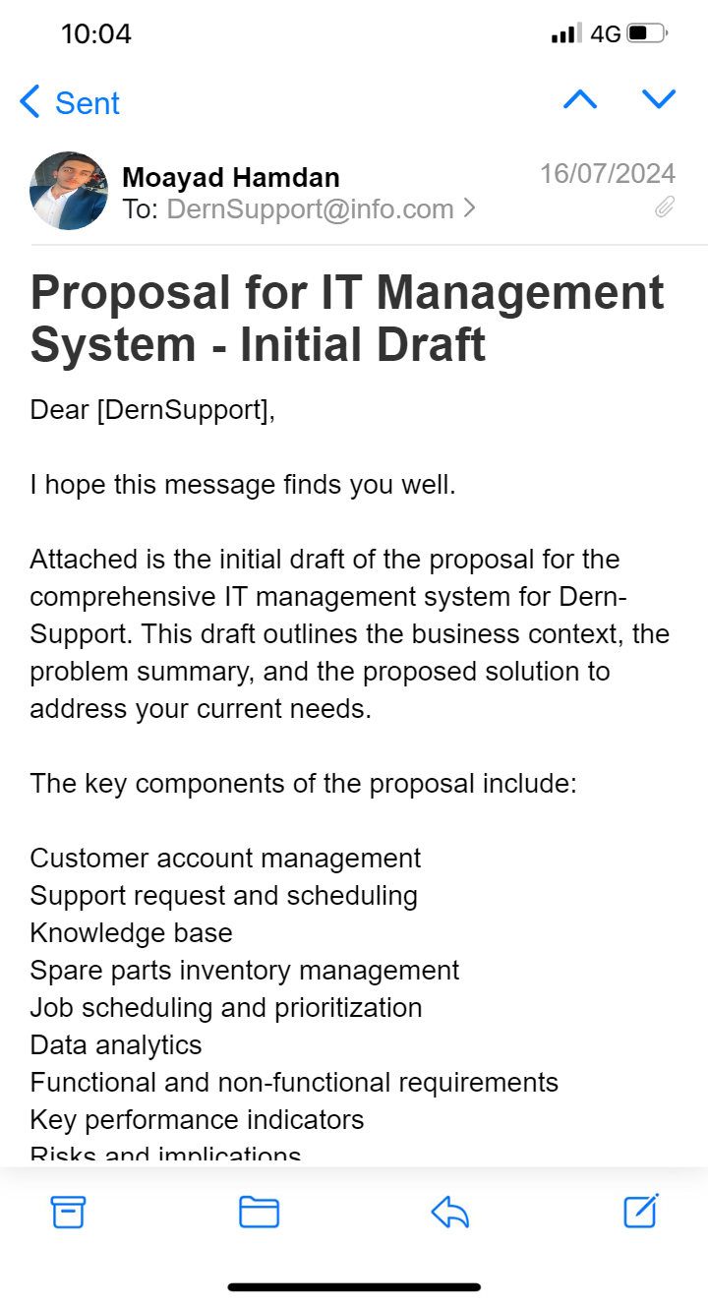

Figure 1me to client 1

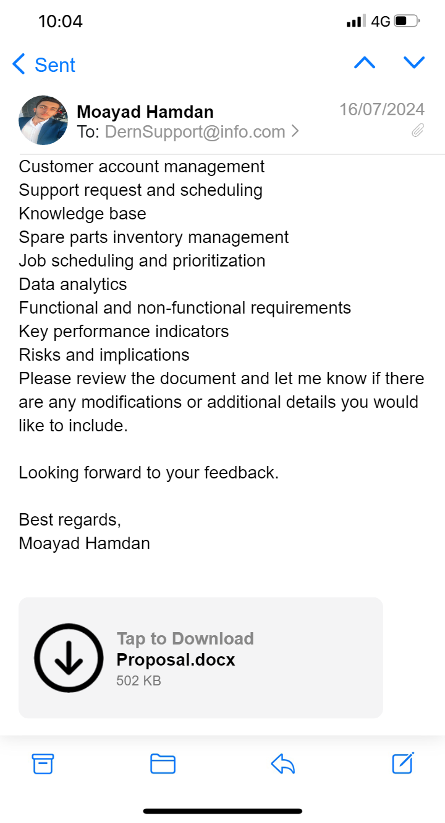

Figure 2 me to client 2

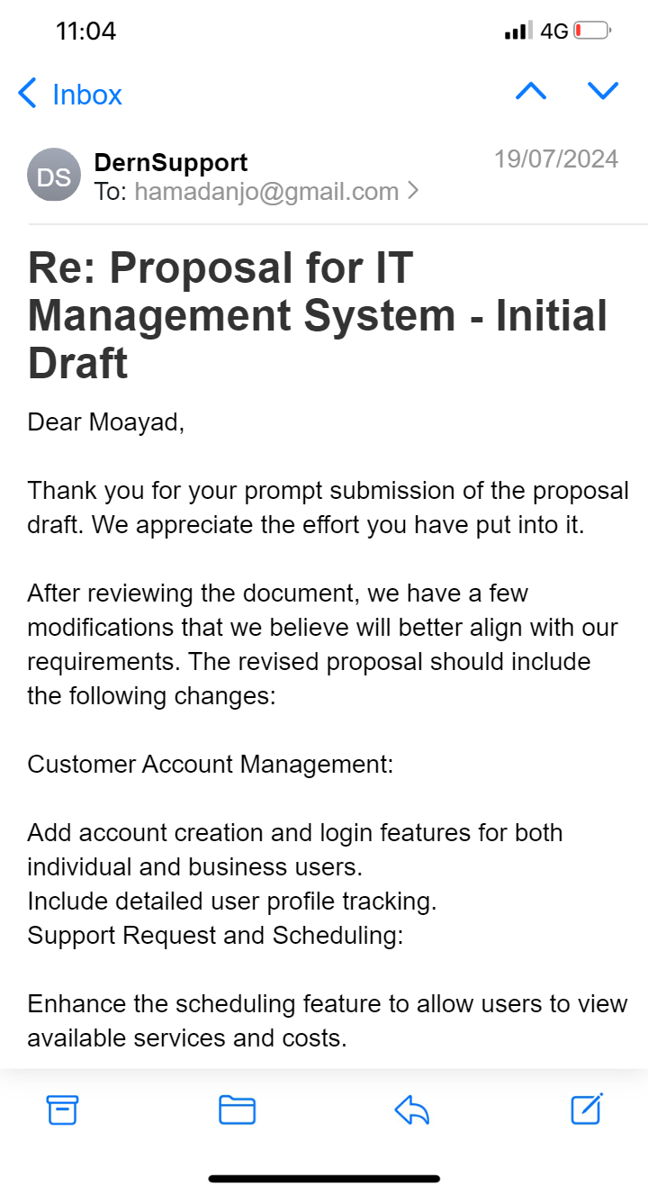

Figure 3 client to me 1

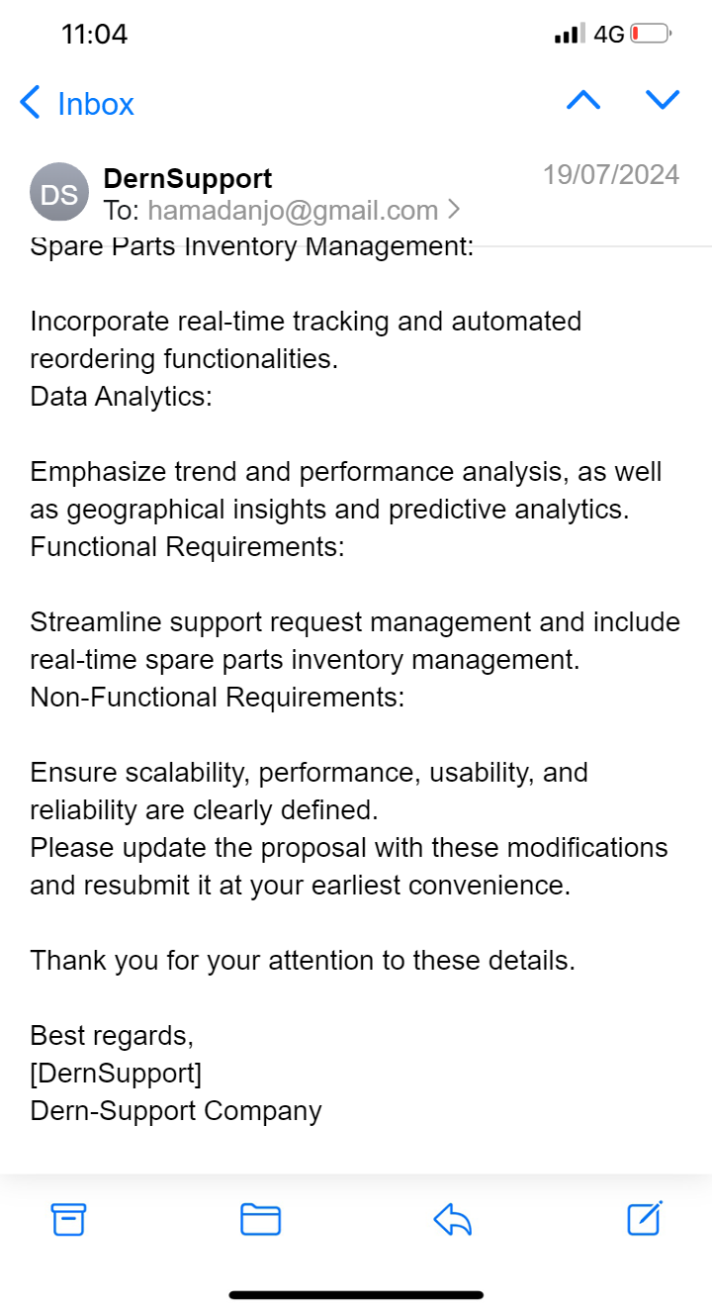

Figure 4 client to me 2

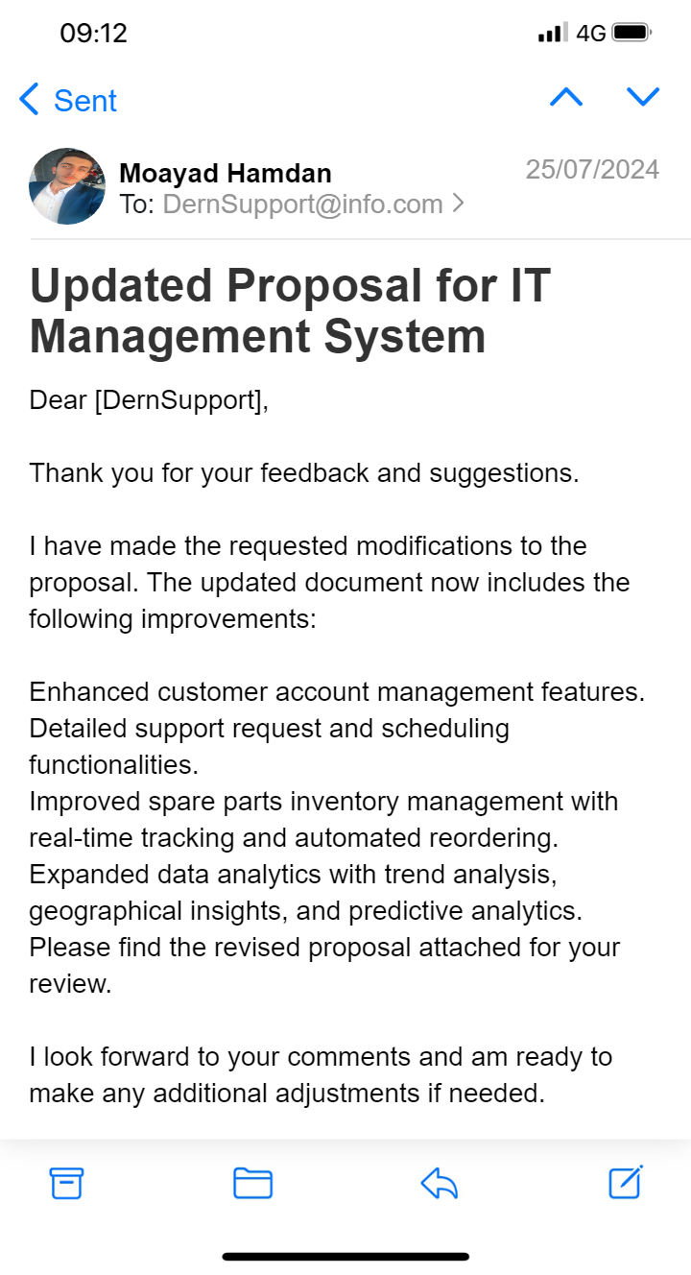

Figure 5 me to client 3

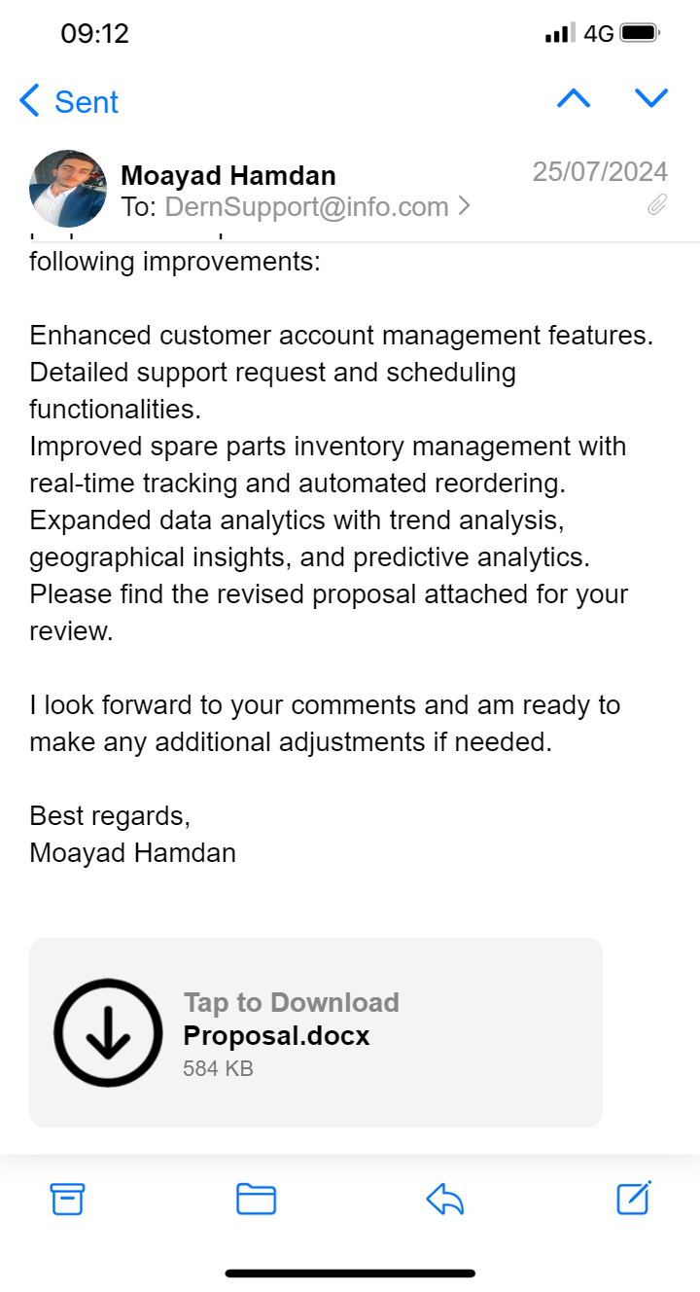

Figure 6 me to client 4

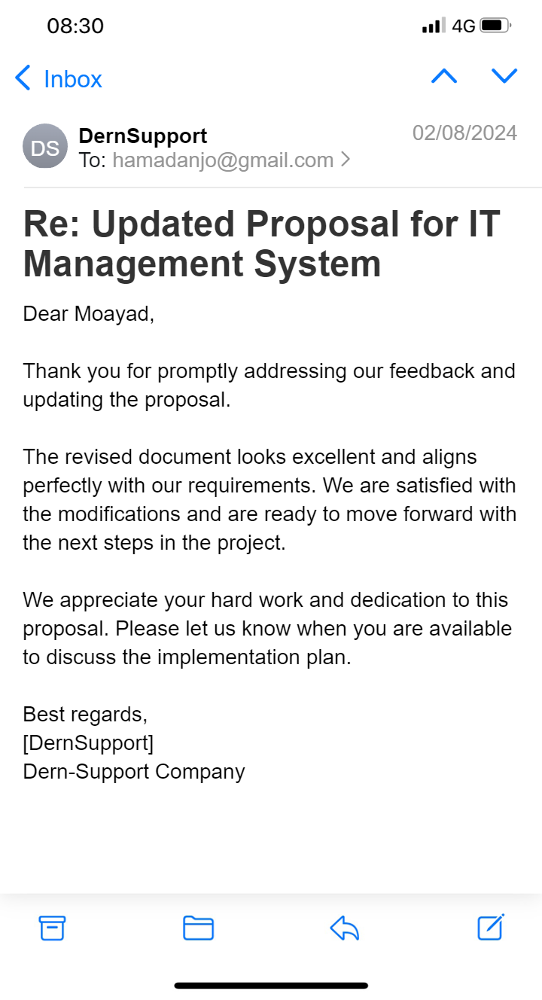

Figure 7 client to me 3

## Proposal for Full Stack Solution After Refinement

### Business Context and Problem Summary

#### Business Context:

Dern-Support is a small but growing IT support company specializing in computer repairs for both businesses and individuals. They provide on-site support for business clients, while individual customers must drop off their computers at one of Dern-Support’s offices or arrange for courier delivery. As the company expands, there is a need for a more efficient system to manage operations and customer interactions effectively.

#### **Summary of the Problem:**

Currently, Dern-Support lacks an integrated system for managing customer accounts, support requests, scheduling, inventory, and data analysis. This leads to inefficiencies, longer response times, and disjointed processes. There is also a lack of tools for management to analyze data trends and make informed decisions. To support growth and improve customer satisfaction, Dern-Support requires a comprehensive software solution.

### Description of the Proposed Solution

The proposed solution is a full-stack web application designed to address the identified challenges and meet Dern-Support’s operational requirements. The solution includes the following key features:

#### ****Customer Account Management:****

##### Account Creation and Login:

1. Users can create accounts as either individual or business users.
2. Business accounts support multiple users under a single account.
3. Both types of accounts have login capabilities.

##### User Profiles:

Individual users and Business accounts can track their repair requests and service history

#### **Support Request and Scheduling:**

1. **Support Request Submission:**
2. Users can submit support requests via a user-friendly web interface.
3. They can provide a title, description, and view the status of their requests.
4. **Scheduling Repairs:** Users can view available services, costs, and schedule repair appointments for specific dates.

#### **Knowledge Base:**

1. **Diagnostic Tools:** Users have access to diagnostic tools for identifying common IT issues.
2. **Instructional Guides:** Offers step-by-step guides for resolving minor issues and frequently asked questions.

#### **Spare Parts Inventory Management:**

1. **Inventory Search:** Search functionality to find details about spare parts in stock.
2. **Inventory Tracking:** Real-time tracking of inventory levels, with alerts for low stock and automated reordering.
3. **Inventory Editing:** Include Save and Delete options for managing spare parts inventory to optimize resource utilization.
4. **Real-Time Tracking:** Track inventory levels in real-time with alerts for low stock and automated reorder suggestions.

#### Spare Parts Inventory Management:

#### Inventory Tracking and Management:

1. Admins can view and manage spare parts inventory.
2. Includes functionalities to search for parts, edit details, and track inventory levels with real-time updates and alerts.

#### **Job **Scheduling** and Prioritization:**

#### Job Management**:**

1. Admins can manage daily repair jobs, optimizing technician availability and workload.
2. Includes prioritization of urgent repair requests

#### **Data Analytics:**

1. **Trend and Performance Analysis:** Provides analytics for identifying common issues, tracking repair times, and monitoring customer satisfaction.
2. **Management Dashboard:** A comprehensive dashboard for real-time analytics and decision-making.
3. **Geographical Insights** **Geographical Insights and Predictive Analytics:** Maps business support jobs and forecasts potential issues based on historical data.

### Functional and Non-Functional Requirements

#### **Functional Requirements:**

1. **Support Request Management:** Submission, tracking, and updating of support requests.
2. **Knowledge Base:** Diagnostic tools and instructional guides.
3. **Inventory Management:** Real-time tracking, searching, and editing of inventory.
4. **Job Management:** Scheduling and prioritization of repair jobs.
5. **Real-time spare parts** inventory management.
6. **Data Analytics:** Real-time analytics and reporting dashboard.

#### **Non-Functional Requirements:**

1. **Scalability:** Support growth in users and data.
2. **Performance:** Response times under 2 seconds for key operations.
3. **Usability:** User-friendly interfaces designed for ease of use.
4. **Reliability:** Target uptime of 99.9% and robust disaster recovery.

### Key Performance Indicators (KPIs)

#### **Operational Efficiency:**

1. **Resolution Time:** Measure the average time taken to resolve support requests.
2. **Daily Requests:** Track the number of support requests handled daily.

#### **System Performance:**

1. **Response Time:** Monitor the average response time for key user interactions, aiming for under 2 seconds.
2. **Uptime:** Track system uptime with a target of 99.9% availability.

#### **Inventory Management:**

1. **Accuracy:** Measure the accuracy of inventory records by comparing system data with physical counts.
2. **Restocking Time:** Track the time taken to reorder and restock parts.

### Risks and Implications of the Proposed Solution

#### **Risks:**

1. **System Downtime:** Mitigation with backup and disaster recovery plans. Mitigation: Robust backup and disaster recovery plans.
2. **Data Integrity:** Regular backups and integrity checks.

Mitigation: Regular data backups and integrity checks.

1. **User Adoption:** Mitigation with training and support.

Mitigation: Comprehensive training and user support.

1. **Budget Overruns:** Mitigation with detailed planning and contingency budgeting.

#### **Implications:**

1. **Positive Implications:**
2. **Better Decision-Making:** Data-driven insights for better management decisions.
3. **Negative Implications:**
4. **Initial Costs:** Development and deployment costs, including potential training expenses.
5. **Maintenance Requirements:** Ongoing maintenance and support.
6. **Change Management:** Potential disruption during the transition to the new system, requiring careful change management.

# Task 1b: ****Design and Documentation****

## Software Design Document

### 1. Functional and Non-Functional Requirements Specifications

#### Functional Requirements:

* **User Management:** Users can register, log in, and manage profiles.
* **Support Request Management:** Users can submit, track, and update support requests.
* **Scheduling:** Users can view available slots and schedule repairs.
* **Inventory Management:** Admins can track and manage spare parts inventory.
* **Data Analytics:** Dashboard for trend analysis and performance tracking.

#### Non-Functional Requirements:

* **Scalability:** System should handle increasing user load and data volume.
* **Performance:** Operations should have a response time under 2 seconds.
* **Usability:** Interfaces should be intuitive and user-friendly.
* **Reliability:** System uptime should be 99.9%, with robust backup plans.

#### Image:

* **Functional Requirements:**

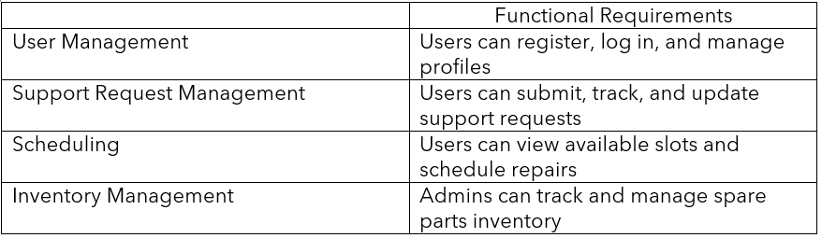

Figure 8 Functional Requirements

* **Non-Functional Requirements:**

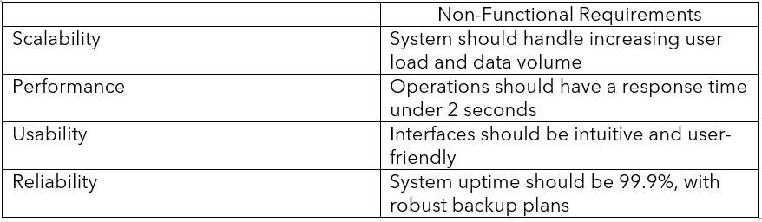

Figure 9 Non-Functional Requirements

### 2. Algorithm Design Documentation

#### Algorithm Design:

* **Flow Charts:**

**Explanation:**

1. **User Registration Process**:
   * Users either log in if registered or go through the registration process.
   * Includes form validation and error handling.
2. **Dashboard and User Profiles**:
   * After login, users can access their profile or proceed to support requests.
3. **Support Request Handling**:
   * Users submit support requests, which are validated and logged. Admins process and assign technicians, schedule repairs, and close requests.
4. **Knowledge Base**:
   * Users can access diagnostic tools and instructional guides.
5. **Spare Parts Inventory Management**:
   * Admins can search and edit inventory, with real-time tracking and updates.
6. **Job Scheduling and Prioritization**:
   * Admins schedule jobs, view services, and prioritize repairs.
7. **Data Analytics**:
   * Provides access to trend and performance analytics.

#### Image:

* **Flow Chart:**

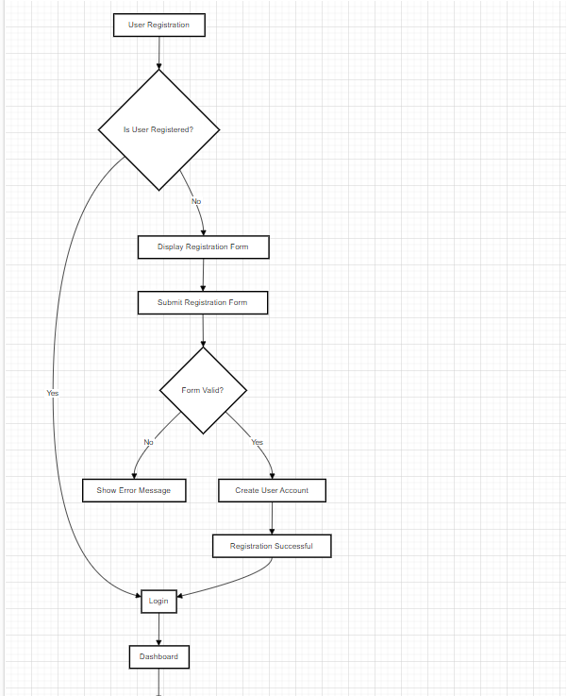

Figure 10 Flow Chart img 1

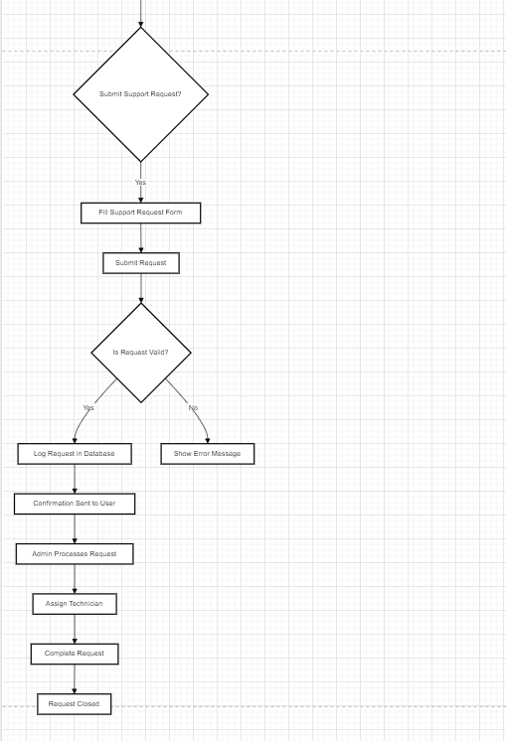

Figure 11 Flow Chart img 2

### 3. Visual Design Documentation

#### Visual Design:

**Wireframes:**

This is the wireframe of the website, showcasing the structure of key pages:

* **Home Page**: The landing page where users can learn about the website and its services.
* **Login Page**: Allows users and admins to log into their accounts.
* **Register Page**: Where users can create a new account, either as a regular user or a business account.
* **Jobs Page**: Displays the scheduled repair jobs for both users and admins.
* **Request Page**: Users can submit a service request with details and track its status.
* **Knowledge Base Page**: Provides common IT issues and solutions for users to explore.

#### Image:

* **Wireframes:**

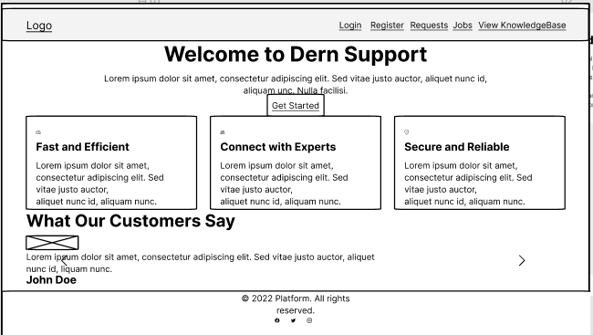

Figure 12 Home Wireframes

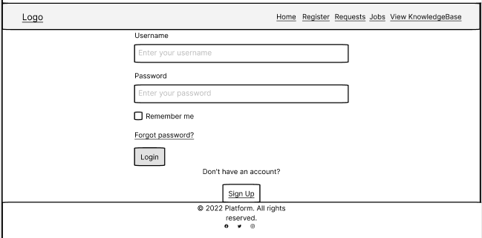

Figure 13 Login Wireframes

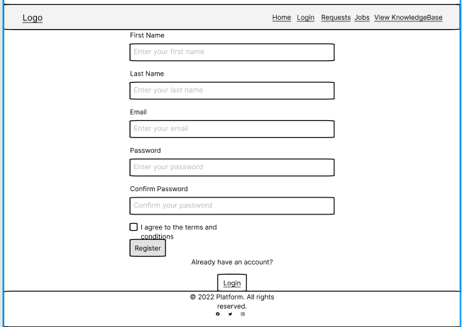

Figure 14 Register Wireframes

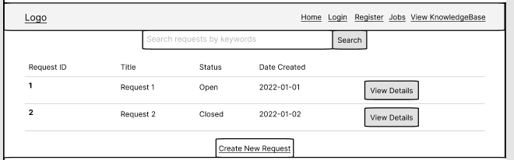

Figure 15 Request Wireframes

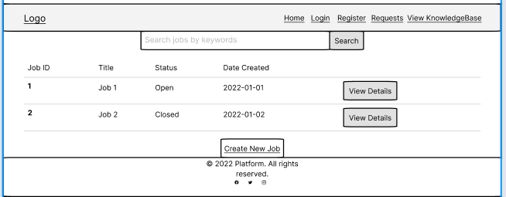

Figure 16 job Wireframes

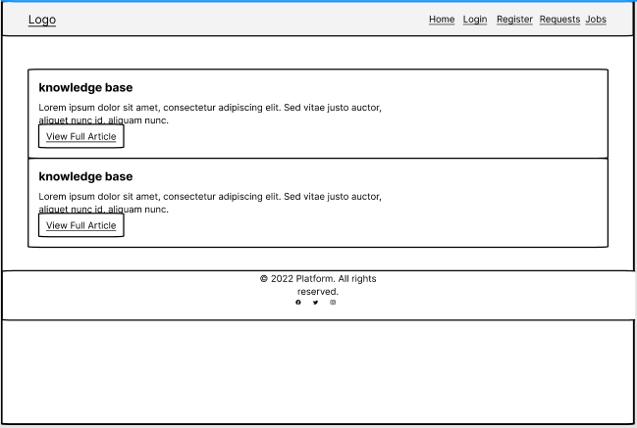

Figure 17 knowledge base Wireframes

### 4. Data Requirements Design

#### Data Requirements:

* **Entity Relationship Diagrams (ERDs):**

**Key Entities:**

* **AspNetUsers**:
* This table stores user information such as Username, Email, and AccountType (likely defining user roles like Admin, Client, or Technician).
* It is connected to other tables that manage user authentication (AspNetUserLogins, AspNetUserTokens, AspNetUserRoles).
* **AspNetRoles**:
* This table defines user roles, with connections to AspNetUserRoles to assign roles to specific users.
* AspNetRoleClaims handles claims (permissions) related to roles.
* **JobsDb**:
* Stores job details such as Title, Description, ScheduledDate, and Priority of tasks that need to be performed, likely by technicians.
* **TechnicianTasksDb**:
* Manages the tasks assigned to technicians. Each task is linked to a TechnicianId and a UserId (the person requesting the task).
* **Technician**:
* This table contains the details of technicians (TechnicianId, FirstName, LastName, Email).
* **TechnicianProjectsDBSet** and **Projects**:
* These tables track which technicians are assigned to which projects. TechnicianProjectsDBSet links technicians to specific projects by TechnicianId and ProjectId.
* Projects contains information about different projects, including the ProjectName and Budget.
* **JobSparePartDb**:
* Likely represents the spare parts used in jobs, with fields for Name, Category, and Description of the parts.
* **KnowledgeBases**:
* This table holds information about common IT issues and solutions, with fields like Title, Description, and Category.

**Connections and Relationships:**

* **User-Role Relationships**:
* AspNetUserRoles links users to roles defined in AspNetRoles, while AspNetUserClaims and AspNetRoleClaims manage specific permissions assigned to users and roles.
* **Technician Assignments**:
* TechnicianTasksDb and TechnicianProjectsDBSet show which tasks or projects are assigned to specific technicians.
* **Job and Inventory Management**:
* JobsDb lists the tasks, and JobSparePartDb manages the spare parts required for those jobs.
* .

#### Image:

* **ERD:**

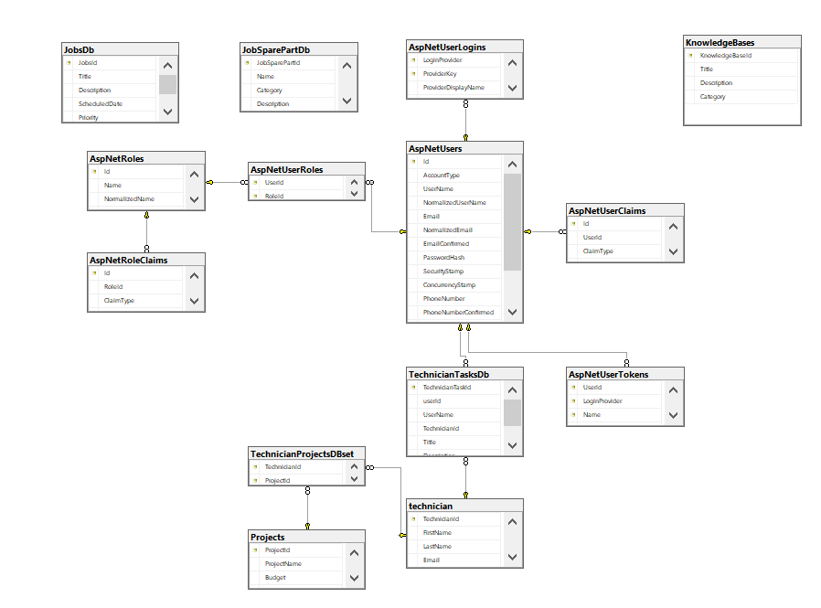

Figure 18 ERD

### 5. Accessibility and Inclusivity Considerations

#### 1. Responsive Design:

1. Adaptability to Devices: Ensure the UI adjusts seamlessly across different screen sizes, including mobile phones, tablets, and desktop monitors. Utilize a responsive design framework (like Bootstrap or Flexbox) to achieve this adaptability.
2. Fluid Layouts: Implement fluid grids and flexible images that resize based on the screen size to maintain usability and aesthetics on various devices.
3. Breakpoints: Define breakpoints in CSS to adjust layouts for different screen resolutions, ensuring that content remains accessible and well-organized regardless of device.

#### 2. Text Size and Contrast:

1. Sufficient Contrast: Adhere to the Web Content Accessibility Guidelines (WCAG) to provide high contrast between text and background colors. This helps users with visual impairments read content more easily.
2. Adjustable Font Sizes: Incorporate features that allow users to adjust font sizes according to their preferences. This can be achieved through scalable units (e.g., em, rem) and user interface controls that enable text resizing.
3. Text Resizing Tools: Integrate browser-based text resizing tools or built-in features in the operating system to accommodate users with different visual needs.

#### 3. Alternative Layouts:

1. Simplified Views: Provide alternative layouts that simplify content for users who may benefit from less complex designs. For example, a “reader mode” that presents content in a clean, distraction-free format.
2. Keyboard Navigation: Ensure that all interactive elements (buttons, links, forms) are accessible via keyboard navigation. Implement proper tab indices and focus management to support users who rely on keyboards or screen readers.
3. Adjustable Interfaces: Allow users to switch between different interface modes, such as a high-contrast mode for those with visual impairments or a simplified mode for easier navigation.

#### 4. Support for Inclusive Technologies:

1. Screen Readers: Ensure compatibility with screen readers by using semantic HTML and ARIA (Accessible Rich Internet Applications) roles and properties. Test the application with popular screen readers like JAWS, NVDA, or VoiceOver.
2. Speech Recognition: Support speech recognition technologies for users who prefer or require voice commands to navigate and interact with the application.
3. Assistive Devices: Consider compatibility with various assistive devices such as adaptive keyboards, eye-tracking systems, and switch devices. Ensure that your application can be used effectively with these technologies.

#### 5. Mockups and Design Features:

1. Accessible Design Mockups: Include mockups in the design phase that showcase accessible design features, such as high-contrast themes, large clickable areas, and easy-to-read fonts.
2. Design Feedback: Gather feedback from users with disabilities during the design and testing phases to ensure that the design meets their needs and is genuinely inclusive.
3. Accessibility Testing: Conduct thorough accessibility testing using automated tools (like axe or Lighthouse) and manual testing to identify and address any potential accessibility issues.

#### 6. Training and Documentation:

1. User Training: Provide resources and training for users to understand and utilize accessibility features effectively. This may include tutorials, FAQs, and support materials.
2. Developer Guidelines: Create guidelines for developers to follow best practices in accessibility, ensuring that new features and updates maintain high accessibility standards.

### 6. Reused/Refactored Components

#### Components:

##### Reused Code:

Third-Party Libraries:

Identity Framework: Utilized for authentication and user management. This framework is standard in ASP.NET Core for handling user accounts and roles.

Swashbuckle.AspNetCore (Swagger UI): Used for API documentation and testing. Provides a user-friendly interface for exploring and interacting with API endpoints.

AutoMapper: Employed for object-to-object mapping, reducing boilerplate code when converting between entities and DTOs (Data Transfer Objects).

Entity Framework Core: Used for database interactions, including migrations and querying, to manage the application’s data persistence layer.

Bootstrap or Material-UI: Front-end libraries to ensure a responsive and modern UI design.

Custom Libraries or Modules:

Logging and Exception Handling: If previous projects have logging frameworks or error handling mechanisms, they can be reused to maintain consistency and reliability in error management.

##### Refactored Code:

Existing Application Modules:

Account Management: Refactored to support both individual and business accounts. Enhancements may include changes to the account creation process, user roles, and profile management.

Support Request Management: Improved to handle new features like scheduling, status tracking, and integration with the inventory system. This may involve changes to request submission, tracking, and prioritization logic.

Inventory Management: Refactored to include real-time tracking and automated reordering. Existing inventory management logic might be extended to accommodate new requirements like inventory alerts and editing functionalities.

Data Analytics:

Reporting and Dashboard: Refactored or extended to provide advanced analytics, including trend analysis and geographical insights. Existing reports or dashboards might be updated to include new KPIs or visualizations.

Job Scheduling and Prioritization:

Job Management Logic: Updated to incorporate new prioritization rules and scheduling functionalities. This could involve modifications to existing job scheduling algorithms or UI components.

Knowledge Base:

Diagnostic Tools and Guides: Refactored to enhance usability and include additional tools or guides based on user feedback or new requirements.

#### Detailed Description:

##### Reused Code:

Identity Framework:

Description: Used for managing user authentication and authorization. Reused from previous projects to handle user registration, login, and role-based access.

Purpose: Provides a robust and secure method for user management without having to build these features from scratch.

Swashbuckle.AspNetCore (Swagger UI):

Description: A tool for generating interactive API documentation. Reused to facilitate API development and testing.

Purpose: Allows developers to easily explore and test API endpoints, ensuring that the API documentation is accurate and up-to-date.

AutoMapper:

Description: Library for mapping between domain models and DTOs. Reused to streamline the conversion process and reduce manual mapping code.

Purpose: Simplifies the process of transferring data between different layers of the application, improving code maintainability.

Entity Framework Core:

Description: ORM framework for data access. Reused for managing database operations and schema migrations.

Purpose: Provides a consistent approach to data access and manipulation, leveraging existing knowledge and practices.

Bootstrap or Material-UI:

Description: CSS frameworks for styling and layout. Reused to ensure a modern and responsive UI.

Purpose: Enhances the user interface with pre-built components and styles, reducing the need for custom CSS.

#### Refactored Code:

##### Account Management:

Description: Modified to support different account types and enhance user profile management.

Purpose: Provides flexibility to manage both individual and business accounts within the same system.

Support Request Management:

Description: Updated to handle new features such as repair scheduling and status tracking.

Purpose: Improves the efficiency and usability of the support request process, aligning with the new system requirements.

Inventory Management:

Description: Refactored to include real-time tracking and automated inventory management features.

Purpose: Enhances inventory control and management, ensuring better resource utilization and minimizing stockouts.

Data Analytics:

Description: Extended to include new analytical features and reporting capabilities.

Purpose: Provides deeper insights into business operations, helping management make informed decisions based on data.

Job Scheduling and Prioritization:

Description: Improved to support advanced scheduling and job prioritization rules.

Purpose: Optimizes technician workload and ensures timely resolution of urgent repair requests.

Knowledge Base:

Description: Updated to include additional diagnostic tools and instructional guides.

Purpose: Enhances the self-service capabilities for users, reducing the need for direct support interactions.

### Review and Feedback Record

#### Review Process:

1. **Initial Review:**

Feedback Documentation:

Reviewer: Jafar

**Comments:** Jafar reviewed the initial software diagram documentation and provided feedback. He noted that the flow chart needed more details to align with the proposed solution described in the project proposal.

Changes Made:

**Action Taken:** Updated the flow chart to include additional details and ensure alignment with the proposal.

**Details Updated:** Expanded on system functionality and interactions as per the proposal.

1. **Justification:**

Design Decisions:

**Reasoning:** The flow chart was revised to include more comprehensive details to better match the proposed solution. This alignment ensures that the diagram accurately reflects the system’s design and functionality, improving clarity and coherence.

**Meeting Requirements:** The updated flow chart now captures all necessary components and interactions, providing a clear visual representation of the system in accordance with the proposal.

**Image Example:**

Feedback and Changes:

Table of Feedback and Updates:

|  |  |  |  |  |  |
| --- | --- | --- | --- | --- | --- |
| |  | | --- | | **Feedback from Jafar** |  |  | | --- | |  | | | **Changes Made** | | --- |  |  | | --- | |  | |
| |  | | --- | | Update the flow chart to include more details. |  |  | | --- | |  | | |  | | --- | | Expanded the flow chart to detail all system components and interactions as described in the proposal. |  |  | | --- | |  | |
| |  | | --- | | Ensure alignment with the proposed solution. |  |  | | --- | |  | | Adjusted the flow chart to reflect the specific functionalities and requirements outlined in the proposal. |

Justification:

Written Explanation:

The flow chart was revised to address the feedback by incorporating additional details that align with the project proposal. This includes a more detailed breakdown of the system’s components and interactions, ensuring that the diagram accurately represents the proposed solution.

Visuals:

Attached are the updated flow chart images demonstrating the enhanced detail and alignment with the proposal.

**Image**:  
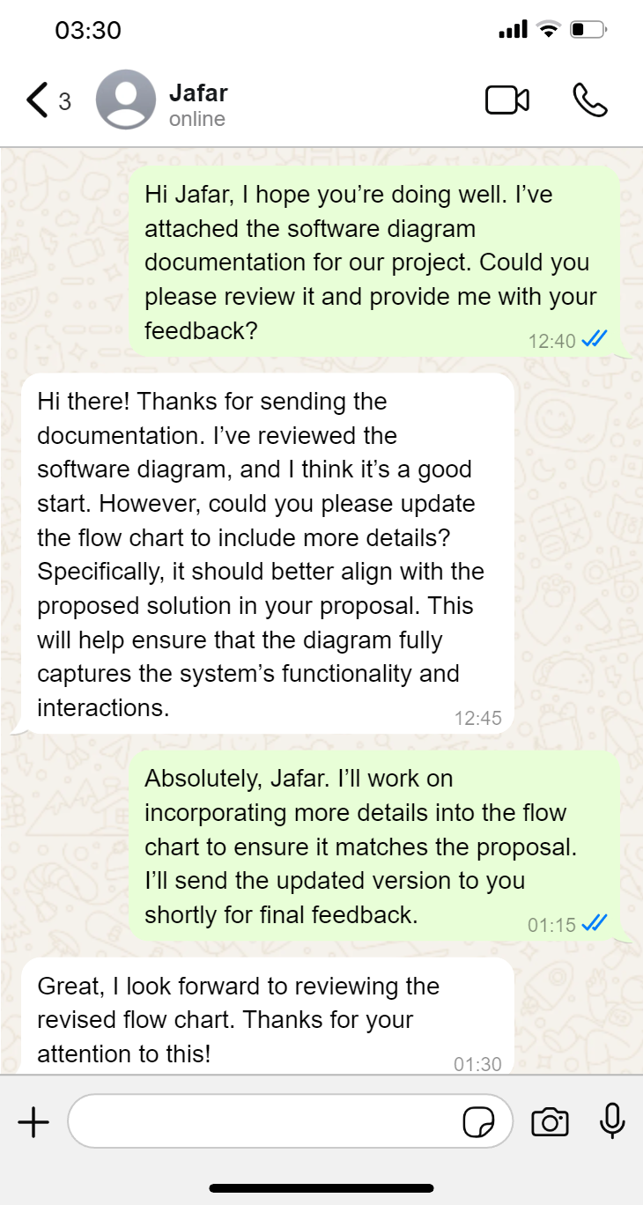

Figure 19 Feedback One 1

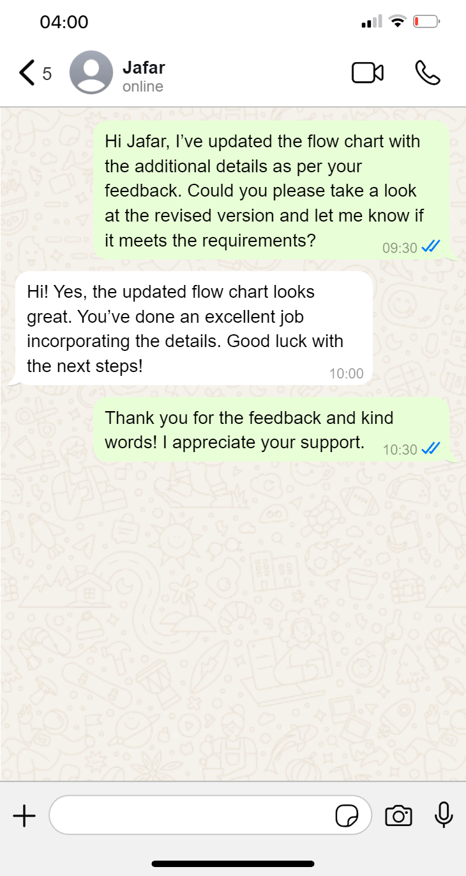

Figure 20 Feedback One 2

### Justification of design decisions and update design for Flow Chart

* New **Flow Chart:**

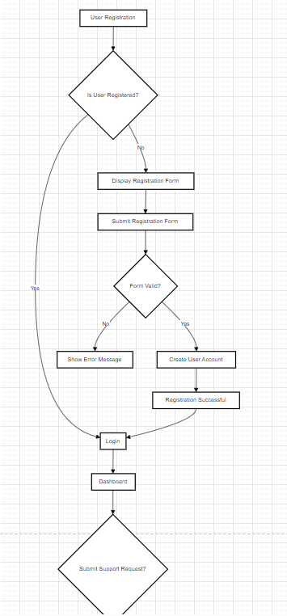

Figure 21 New Flow Chart 1

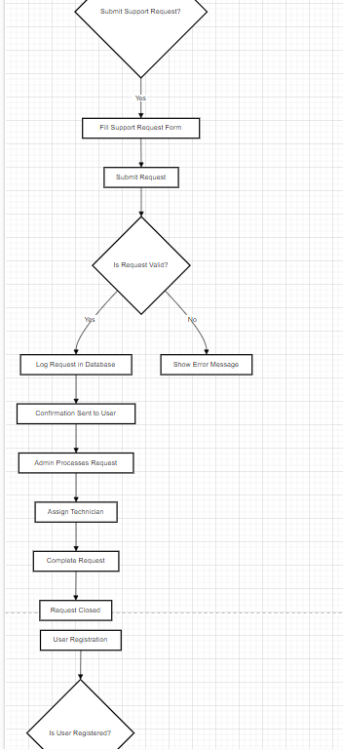

Figure 22 New Flow Chart 2

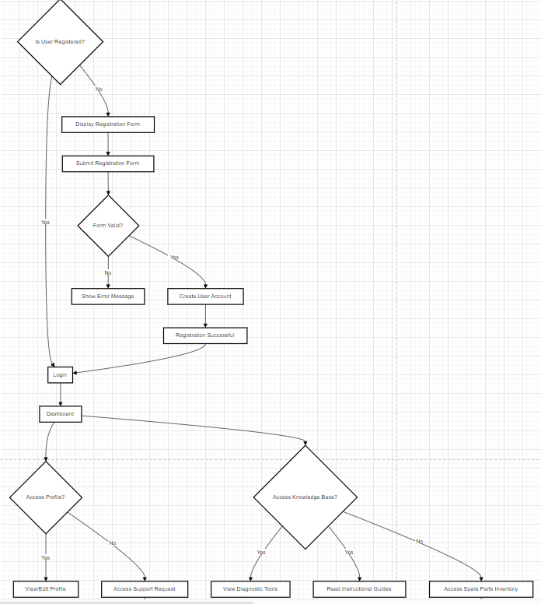

Figure 23 New Flow Chart 3

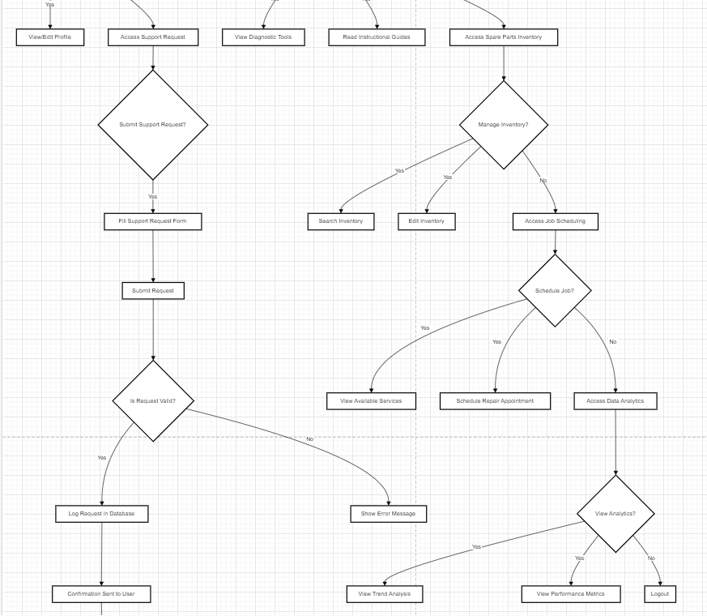

Figure 24 New Flow Chart 4

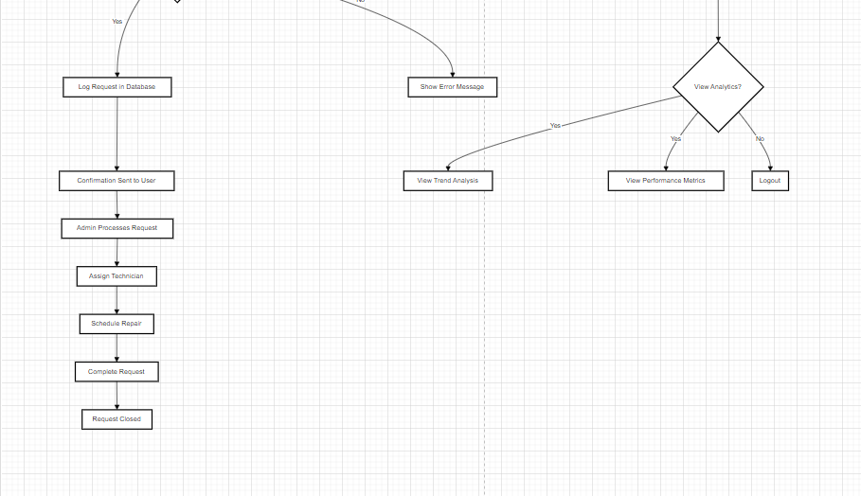

Figure 25 New Flow Chart 5

#### Review Process:

1. **Initial Review:**

Feedback Documentation:

Reviewer: Raghad

**Comments:** Raghad reviewed the wireframes and requested that the search button be removed from all wireframes except for the IT Stocks page.

**Changes Made:**

**Action Taken:** Updated the wireframes to remove the search button from all pages, keeping it only on the IT Stocks page.

**Details Updated:** Removed the search button from all pages except for the IT Stocks page.

1. **Justification:**

Design Decisions:

Reasoning: The wireframes were revised based on Raghad's feedback to simplify the user interface and improve the browsing experience. Keeping the search button only on the IT Stocks page helps users find specific IT Stocks more easily without duplicating the search functionality across multiple pages.

Meeting Requirements: The changes make the user interface more organized and support the goal of providing a clearer user experience without overwhelming users with repeated search options.

**Image Example:**

Feedback and Changes:

Table of Feedback and Updates:

|  |  |  |  |  |  |
| --- | --- | --- | --- | --- | --- |
| |  | | --- | | **Feedback from Raghad** |  |  | | --- | |  | | | **Changes Made** | | --- |  |  | | --- | |  | |
| |  | | --- | | Remove the search button from all pages, keeping it only on the IT Stocks page. |  |  | | --- | |  | | Updated the wireframes to remove the search button from all pages except the IT Stocks page. |

Justification:

Written Explanation:

The wireframes were updated to reflect Raghad's feedback by removing the search button from all pages except the IT Stocks page. This change enhances the organization of the user interface and provides a clearer browsing experience.

Visuals:

Attached are the updated wireframes showing the removal of the search button from various pages, with it retained only on the IT Stocks page.

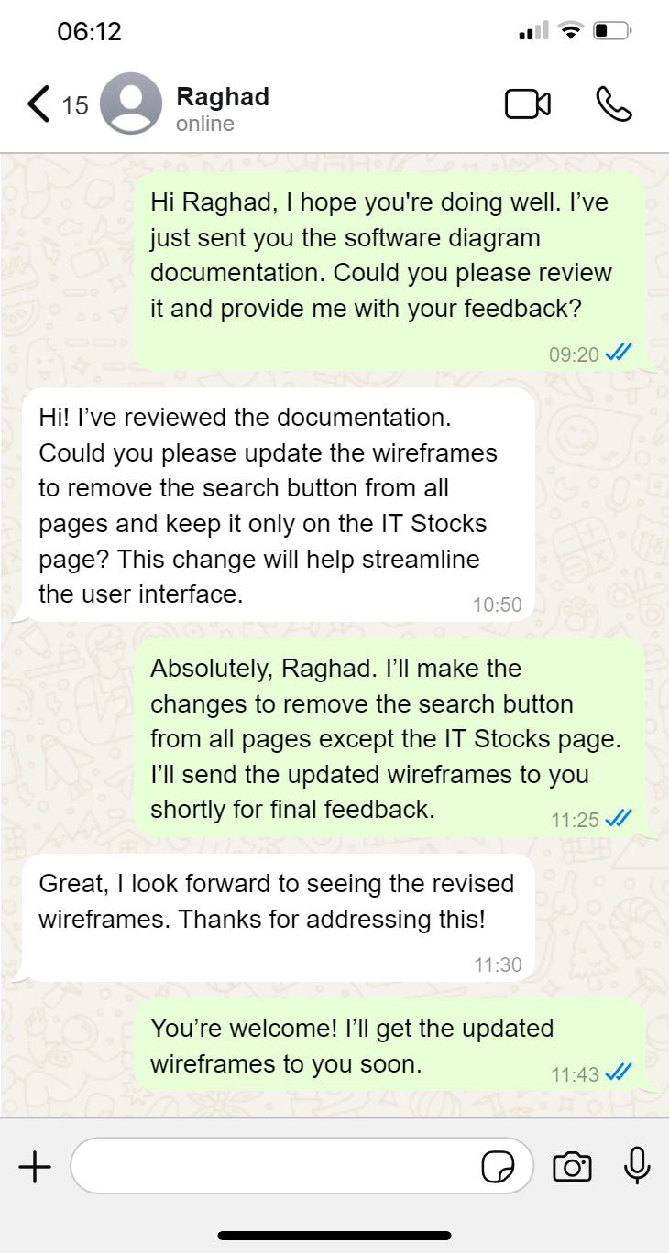

Figure 26 Feedback Two 1

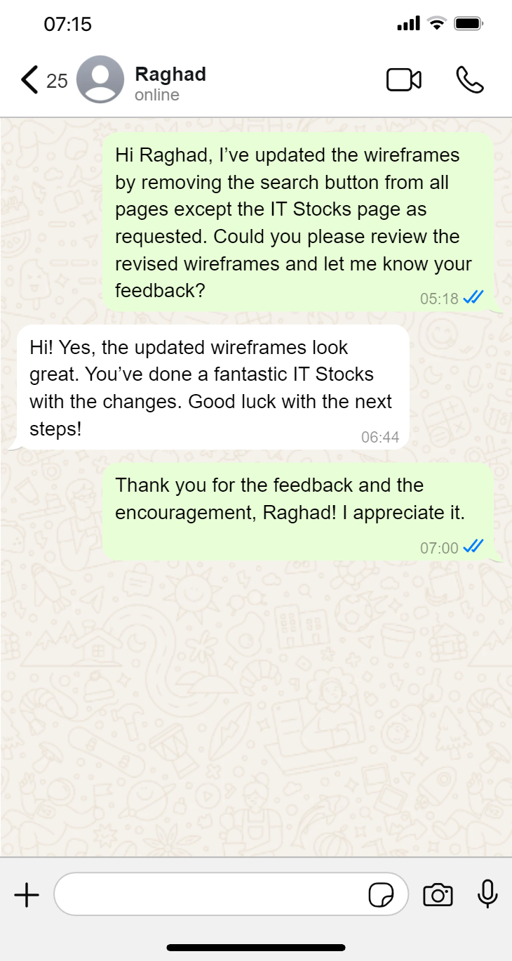

Figure 27 Feedback Two 2

### Justification of design decisions and update design for Wireframes

New **Wireframes:**

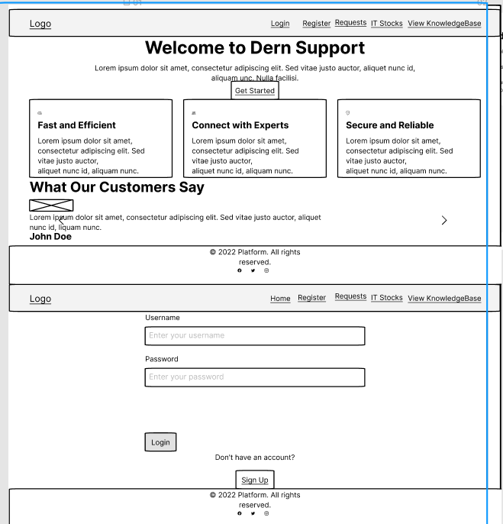

Figure 28 Wireframes 1

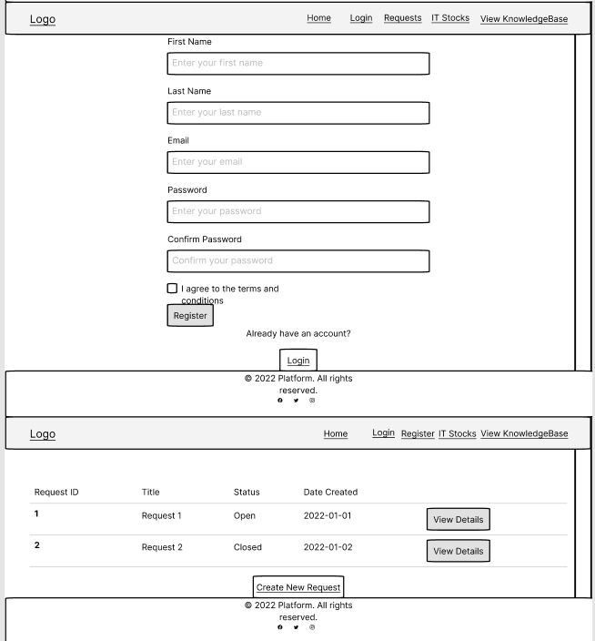

Figure 29 Wireframes 2

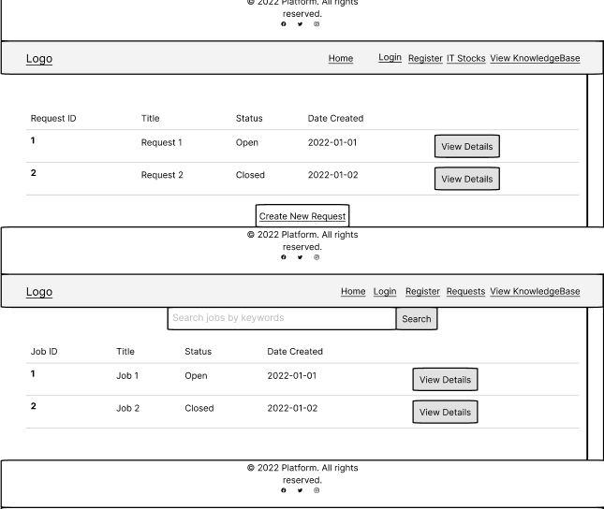

Figure 30 Wireframes 3

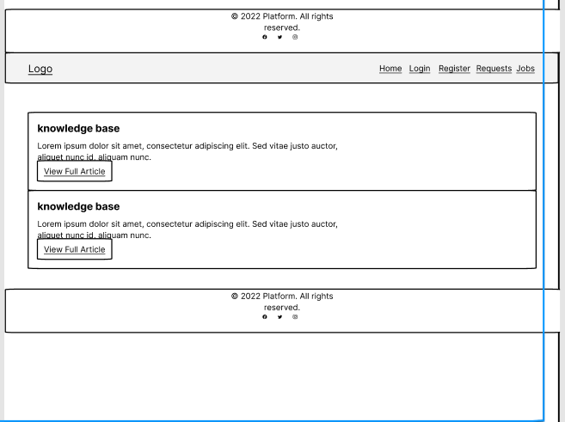

Figure 31 Wireframes 4

# Task 1c: ****Development and Testing****

## Testing, Feedback Analysis, and Evaluation the Software Solution

### Development Process and Tools Used

#### Development Process:

The development of the Dern-Support full-stack solution followed an Agile methodology, focusing on iterative development, continuous testing, and feedback integration. Each sprint involved specific features such as support request management, inventory management, and user account functionality. The development was divided into the following phases:

Requirement Analysis: Gathering and refining requirements from stakeholders.

Design: Creating wireframes, user flow diagrams, and architectural design.

Implementation: Coding using ASP.NET Core for the backend and React for the frontend.

Testing: Conducting live tests and unit tests to ensure functionality, performance, and security.

Feedback Integration: Gathering feedback, analyzing it, and refining the solution based on user input.

#### Tools Used:

IDE: Visual Studio 2022 for backend development with C# ASP.NET Core, Visual Studio Code for frontend development with React and JS.

Version Control: Git and GitHub for source code management and collaboration.

Database Management: SQL Server Management Studio (SSMS) for managing the database, including tables like AspNetUsers, JobsDb, and KnowledgeBases.

Testing Frameworks: xUnit for unit testing, and manual testing scripts for live tests.

Design Tools: Figma for UI/UX design and wireframing.

### Test Plans

#### Test Plan Overview:

A detailed test plan was developed to validate the critical functionalities of the application, ensuring that the system meets the defined requirements and performs well under different conditions. Both unit and live testing approaches were employed.

#### Testing Objectives:

* Verify functionality of key features through direct interaction.
* Ensure performance meets requirements under real-world conditions.
* Validate usability from an end-user perspective.

#### Unit Test Cases:

Unit tests were created to validate individual components of the system, such as account creation, login, inventory updates, and repair scheduling. The tests were designed to ensure accuracy, reliability, and performance.

#### Sample Unit Test Case:

**Test Case:** Validate Account Creation

* + **Objective:** Ensure accounts are created correctly with valid data.
  + **Steps:**
    1. Send a request with valid account information.
    2. Check the database for the new account entry.
  + **Expected Result:** The account is successfully created with correct attributes.
  + **Actual Result:** Passed successfully.

### Issues Encountered and Resolutions

#### Issues and Resolutions:

1. **Slow Response Time:**
   * **Issue:** The application experienced slow response times when submitting support requests during peak hours.
   * **Resolution:** Performance optimizations were implemented, including query optimization and load balancing strategies.
2. **Inventory Sync Issues:**
   * **Issue:** Real-time inventory updates were not reflected immediately.
   * **Resolution:** Integrated real-time notifications for inventory updates, ensuring immediate reflection of changes.
3. **Account Registration Errors:**
   * **Issue:** Errors occurred when registering with an existing username or invalid password.
   * **Resolution:** Added validation checks to prevent registration with an existing username and strengthened password criteria.
4. **Invalid Login Attempts:**
   * **Issue:** Logging in with incorrect credentials was confusing to users.
   * **Resolution:** Improved error messaging for failed login attempts to guide users effectively.
5. **Repair Scheduling Conflicts:**
   * **Issue:** Users were able to schedule repairs with past dates.
   * **Resolution:** Implemented validation checks to restrict date selection to future dates only.

### Live Test Cases and Results

#### Test Case 1: Support Request Submission

* **Objective:** Verify that users can submit support requests.
* **Test Steps:**
  1. Navigate to the support request submission page.
  2. Enter a title and description for a new support request.
  3. Click "Submit" and observe the outcome.
* **Expected Result:** The request should be successfully submitted and visible in the user’s support request history.
* **Actual Result:**

User Page Requests SUBMIT A REQUEST:  
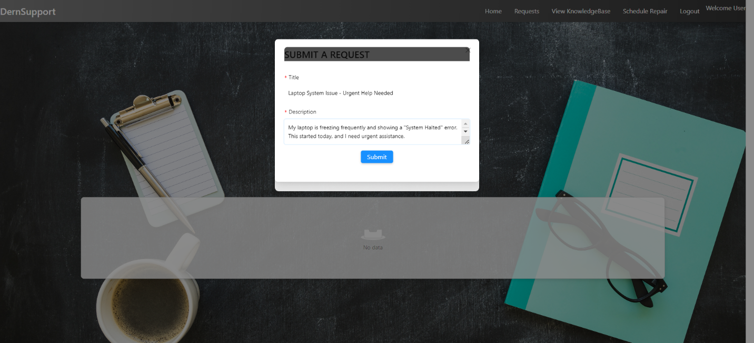

Figure 32 User Page Requests SUBMIT A REQUEST 1

User Page Requests SUBMIT A REQUEST Successful And return it:  
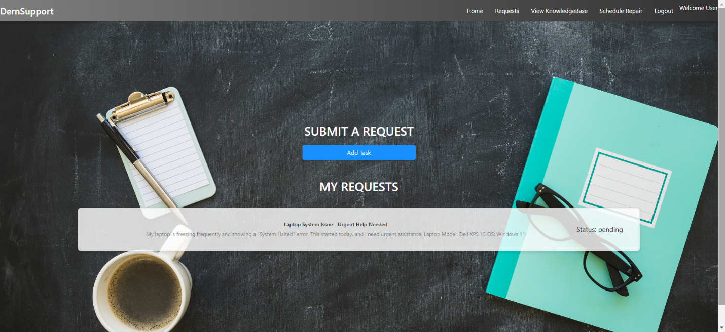

Figure 33 User Page Requests SUBMIT A REQUEST Successful 1

**Observations:** The support request was successfully submitted, and the confirmation message was displayed. The request also appeared in the user's support request history as expected.

#### Test Case 2: Account Creation and Login

* **Objective:** Ensure that both individual and business accounts can be created and logged in.
* **Test Steps:**
  1. Navigate to the account creation page.
  2. Create a new account with valid details.
  3. Log in using the newly created account.
* **Expected Result:** The account should be created successfully, and the user should be able to log in and view their profile.
* **Actual Result:**

Home Page:  
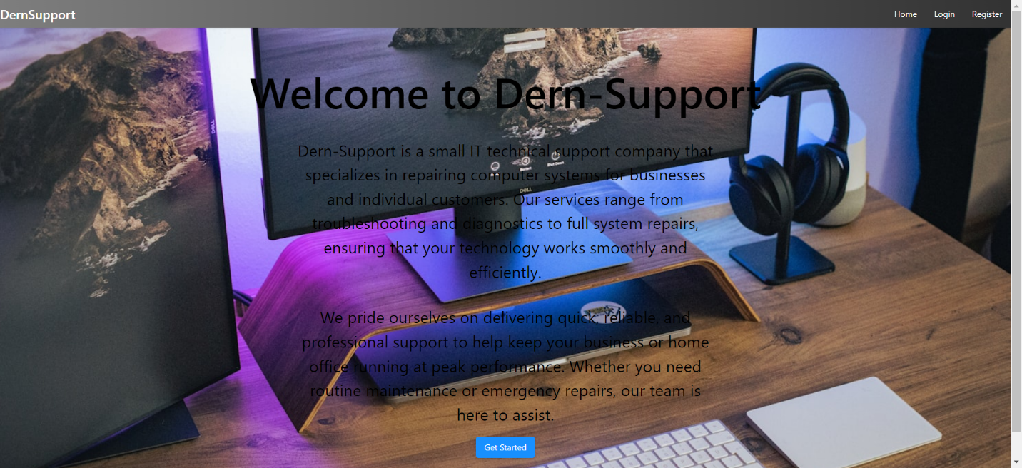

Figure 34 Home Page 1

Register Page:  
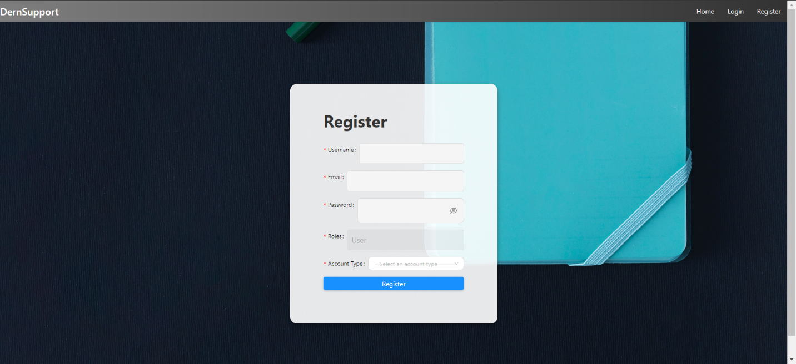

Figure 35 Register Page 1

Register Page Select Account Type:  
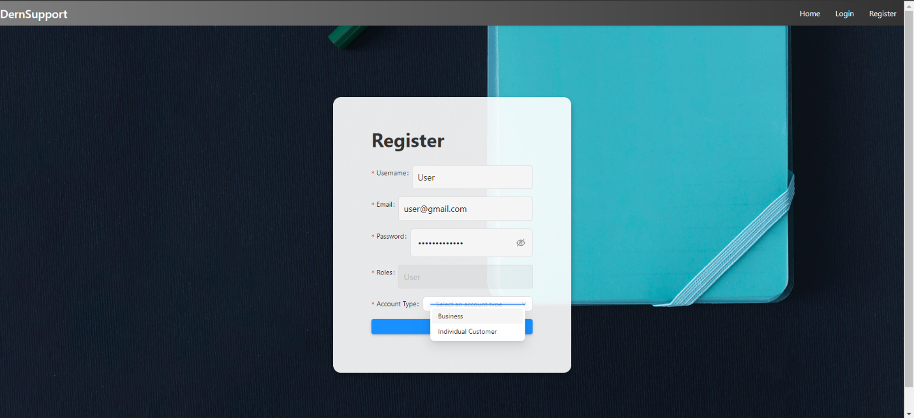

Figure 36 Register Page Select Account Type 1

Register Page Business Account:  
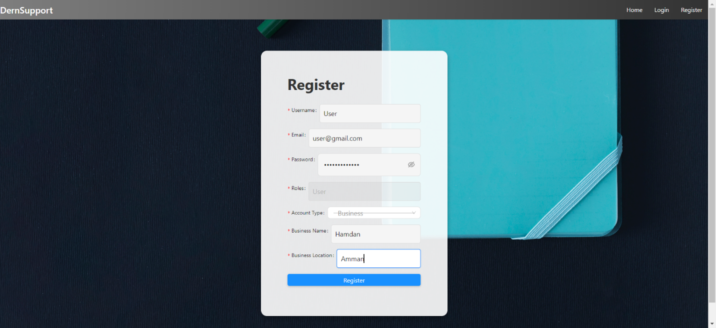

Figure 37 Register Page Business Account 1

Register Page Individual Customer Account:  
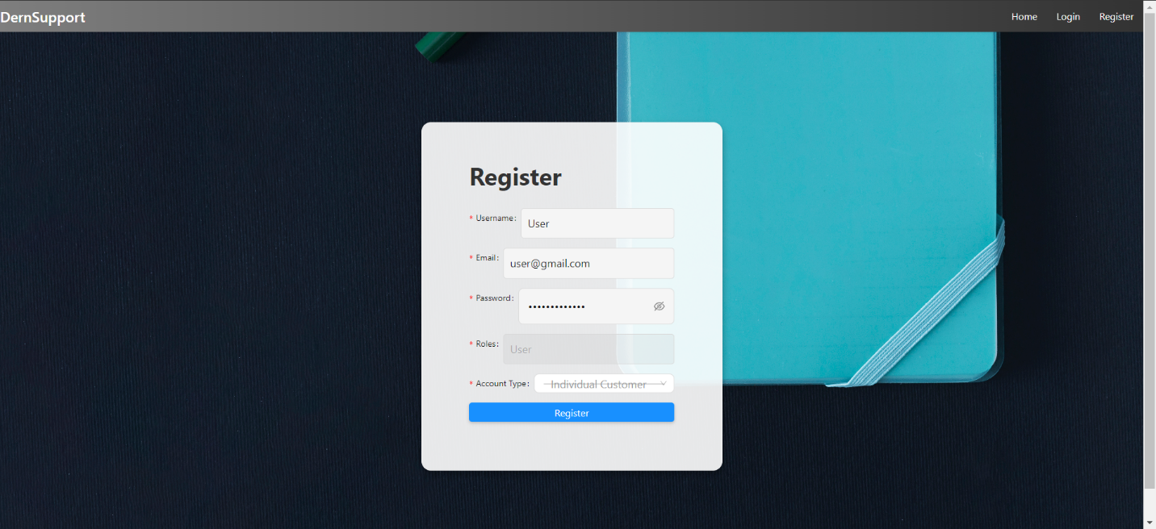

Figure 38 Register Page Individual Customer Account 1

Register Page Registration Successful:  
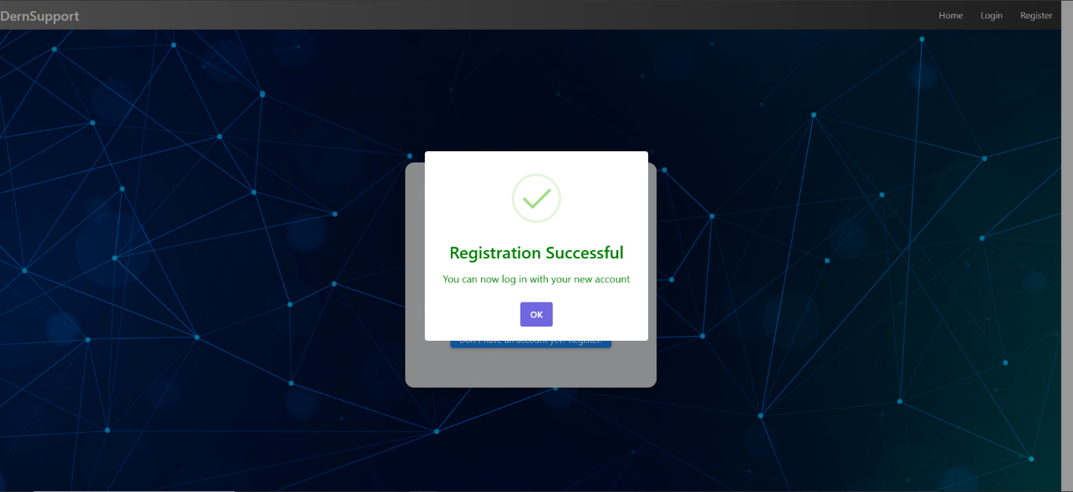

Figure 39 Register Page Registration Successful 1

Login Page:  
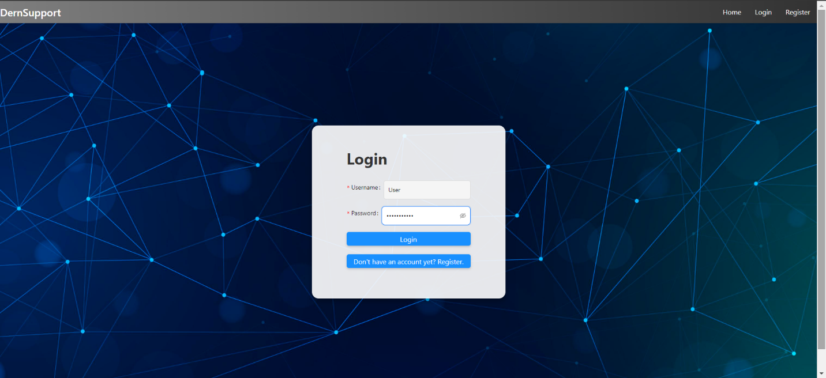

Figure 40 Login Page 1

User Page:  
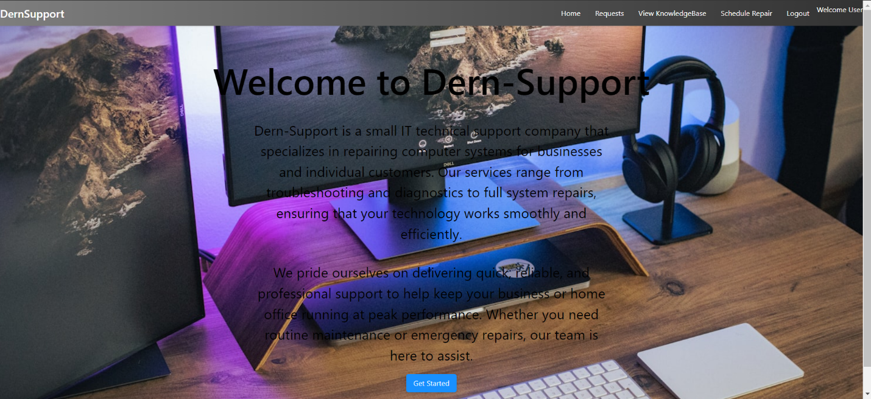

Figure 41 User Page 1

**Observations:** Account creation and login were successful. The user was able to access their profile and view their support requests.

#### Test Case 3: Inventory Management

* **Objective:** Ensure real-time updates in inventory management.
* **Test Steps:**
  1. Navigate to the inventory management page.
  2. Update the inventory for a spare part.
  3. Check if the updated information is reflected immediately.
* **Expected Result:** Inventory updates should be visible in real-time.
* **Actual Result:**

Admin Page IT Stocks:  
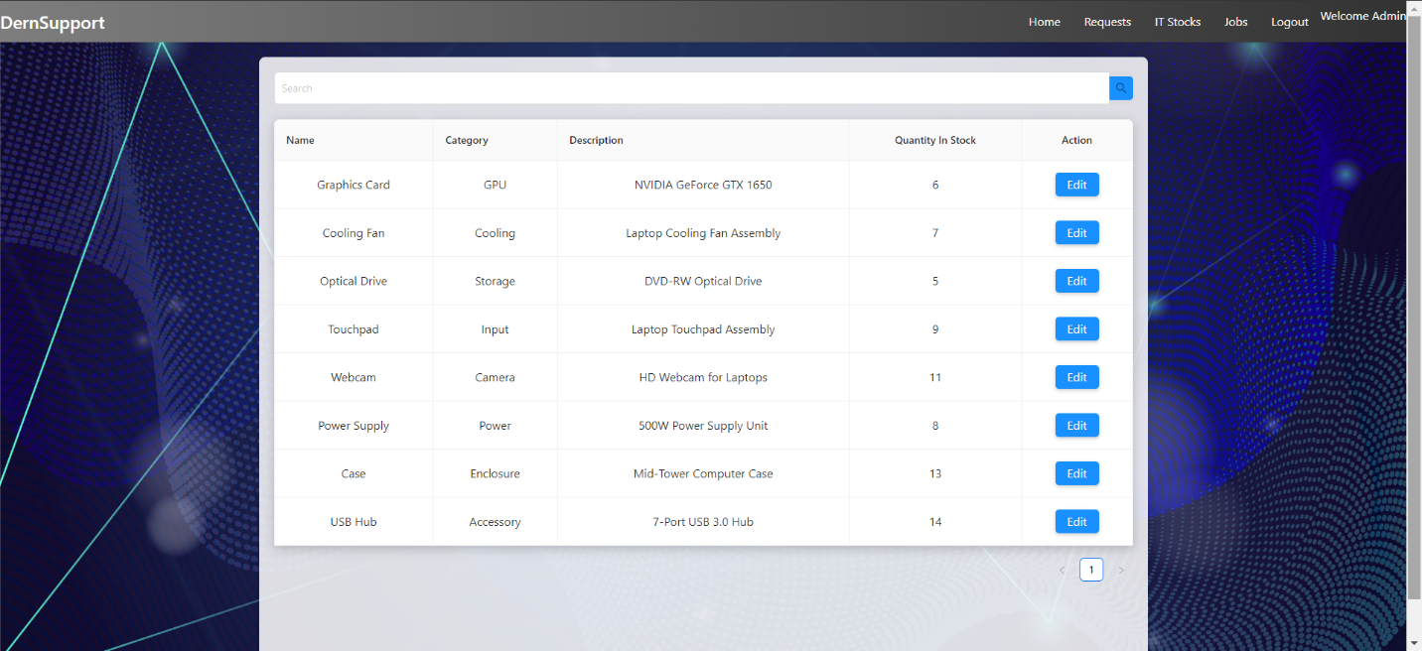

Figure 42 Admin Page IT Stocks 1

Admin Page IT Stocks Search:  
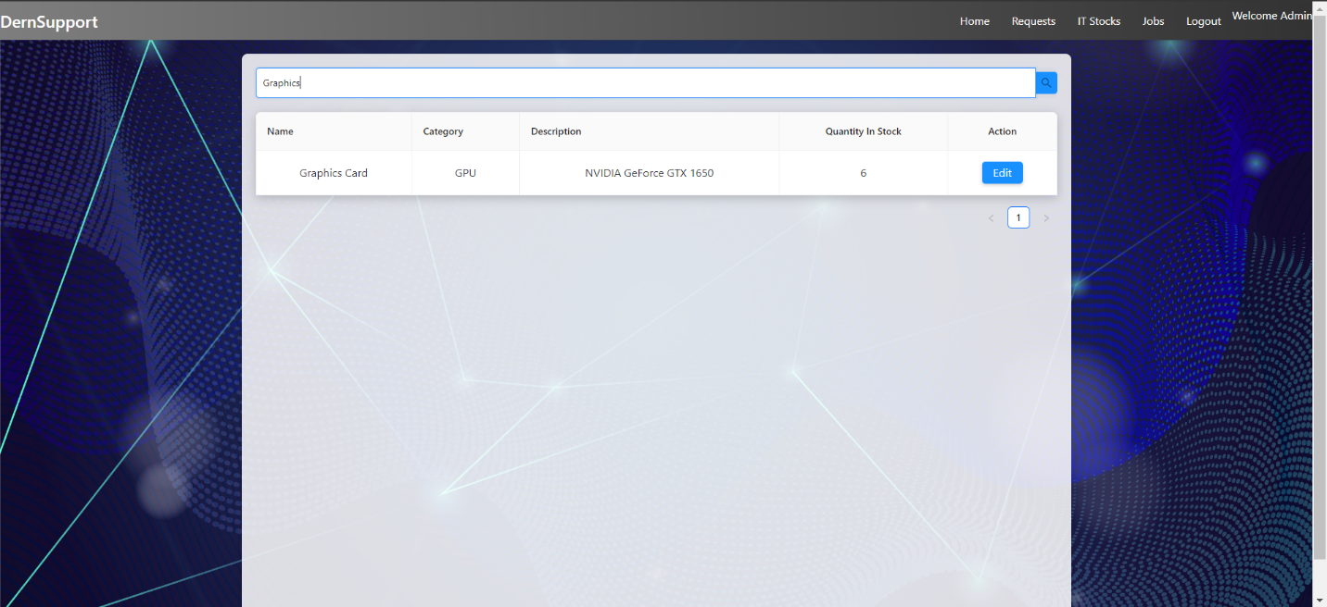

Figure 43 Admin Page IT Stocks Search 1

Admin Page IT Stocks Edit Stock:  
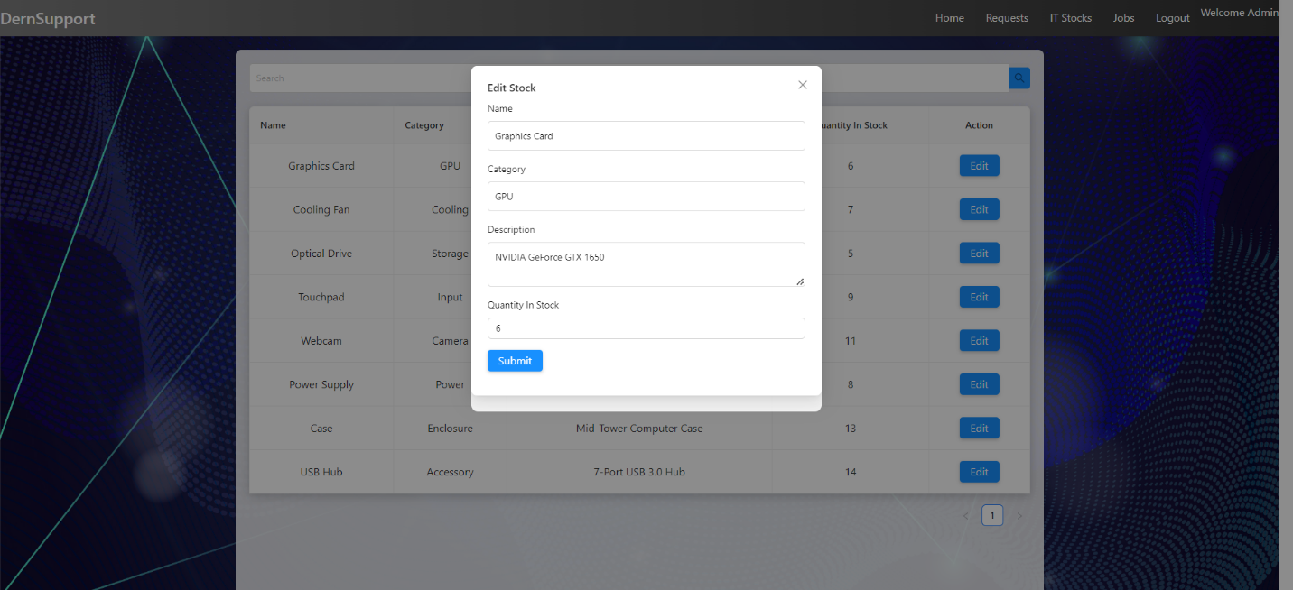

Figure 44 Admin Page IT Stocks Edit Stock 1

Admin Page IT Stocks Edited Stock Successful:  
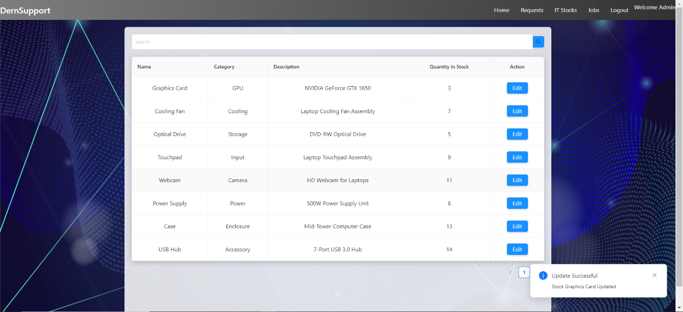

Figure 45 Admin Page IT Stocks Edited Stock Successful 1

**Observations:** The inventory update was reflected in real-time, with updated details visible immediately after the change.

#### Test Case 4: Scheduling Repairs

* **Objective:** Verify that users can schedule repair appointments.
* **Test Steps:**
  1. Navigate to the repair scheduling page.
  2. Choose a service, view available dates, and schedule an appointment.
* **Expected Result:** The repair appointment should be scheduled successfully, and the user should receive a confirmation.
* **Actual Result:**

User Page Schedule Repair:  
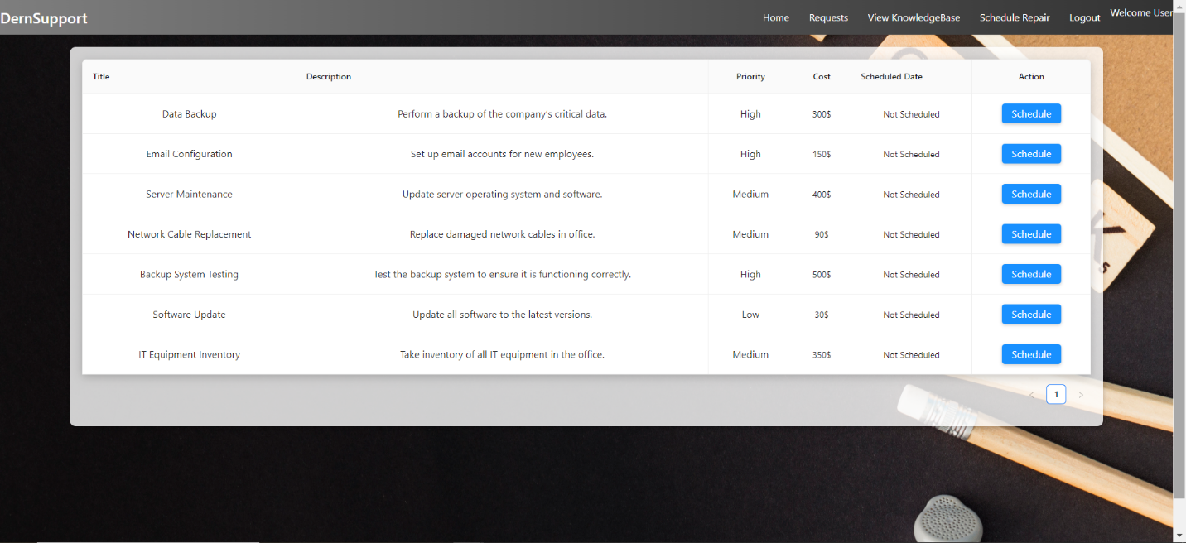

Figure 46 User Page Schedule Repair 1

User Page Schedule Repair Scheduled Date:  
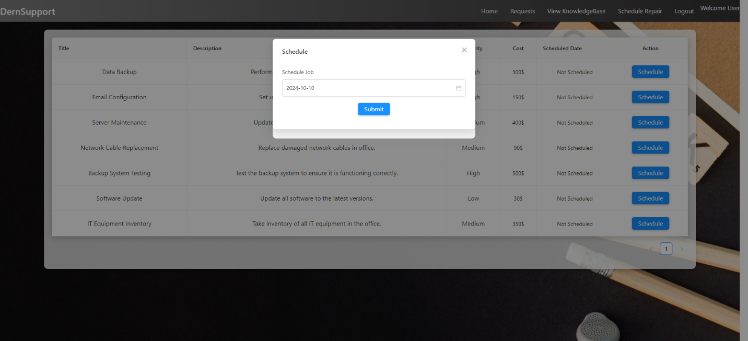

Figure 47 User Page Schedule Repair Scheduled Date 1

User Page Schedule Repair Scheduled Date Schedule Successful:  
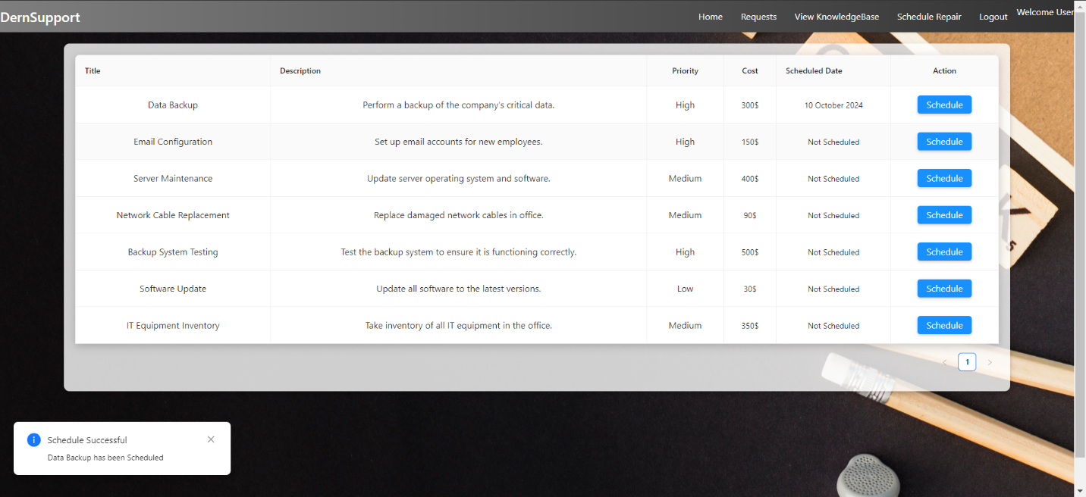

Figure 48 User Page Schedule Repair Scheduled Date 2

**Observations:** Repair scheduling was successful, and a confirmation message was displayed.

#### Test Case 5: User Page View Knowledge Base

* **Objective:** Verify that users can view and access the knowledge base on their profile page.
* **Test Steps:**
  1. **Navigate to the User Profile Page:** Log in to the application and go to the user profile page.
  2. **Access the Knowledge Base:** Locate and click on the "Knowledge Base" section or link on the user profile page.
  3. **View Knowledge Base Content:** Browse through the available diagnostic tools and instructional guides. Click on specific items to view detailed information.
* **Expected Result:**
* The user should be able to access the knowledge base from their profile page.
* Users should be able to view and navigate through the diagnostic tools and instructional guides.
* Clicking on individual items should display detailed content correctly.
* **Actual Result:**

User Page View KnowledgeBase:

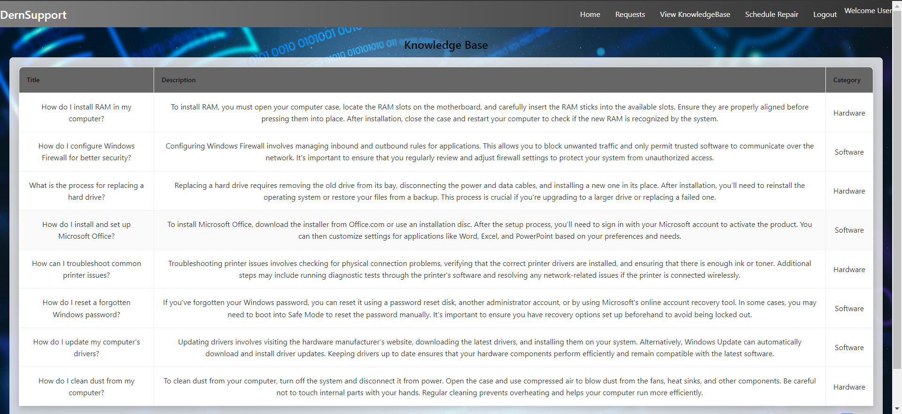

Figure 49 User Page View KnowledgeBase 1

* **Observations:**
  + The knowledge base section was successfully accessible from the user profile page.
  + Users could browse and view diagnostic tools and instructional guides without issues.
  + All content displayed correctly, and navigation was smooth.

#### Test Case 6: Admin Page - Manage Requests and Jobs

* **Objective:** Verify that admins can view and manage declined and approved support requests, as well as view job details on the admin page.
* **Test Steps:**
  1. **Navigate to the Admin Dashboard:** Log in to the application as an admin and access the admin dashboard.
  2. **View Declined Requests:**

Locate and click on the "Declined Requests" section or link.

Browse through the list of declined requests to verify that all requests are visible with correct details.

* 1. **View Approved Requests:**

Locate and click on the "Approved Requests" section or link.

Browse through the list of approved requests to verify that all requests are visible with correct details.

* 1. **View Jobs:**

Locate and click on the "Jobs" section or link.

Browse through the list of jobs to ensure all job details, including status and assigned technicians, are visible.

* 1. **Expected Result:**
* Admins should be able to access and view the declined requests section with all declined requests and details.
* Admins should be able to access and view the approved requests section with all approved requests and details.
* Admins should be able to access and view the jobs page with all job details, including status and assigned technicians.
* **Actual Result:**

Admin Page:  
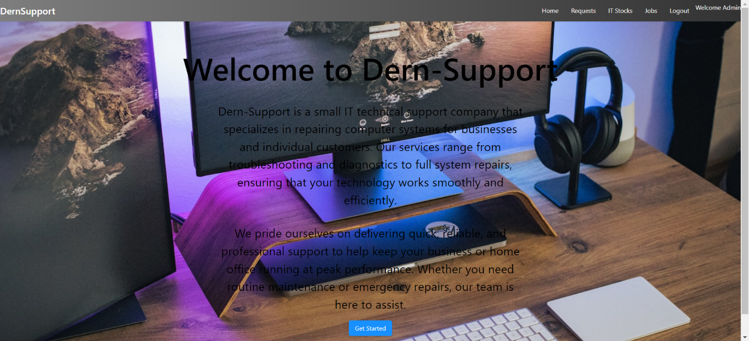

Figure 50 Admin Page 1

Admin Page Requests:  
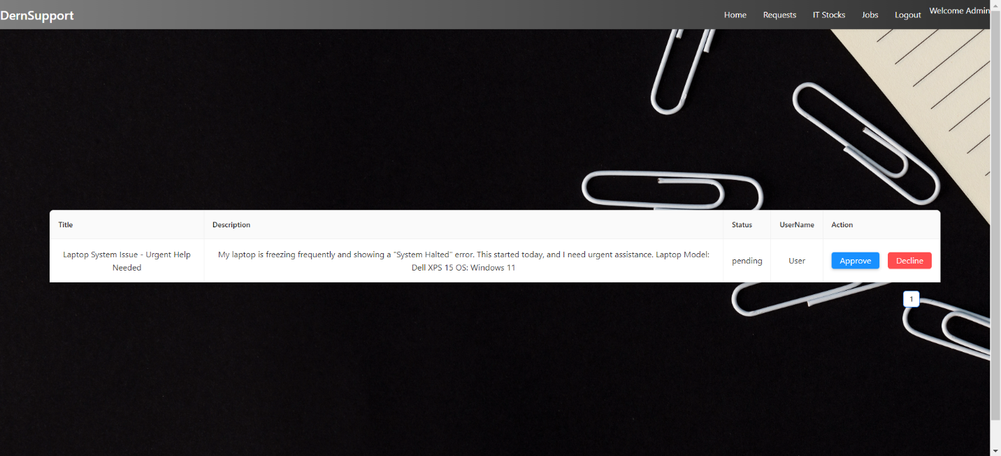

Figure 51 Admin Page Requests 1

Admin Page Requests Approved Request:

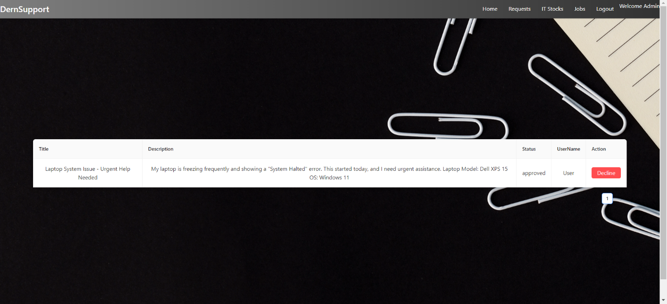

Figure 52 Admin Page Requests Approved Request 1

Admin Page Requests Declined Request:  
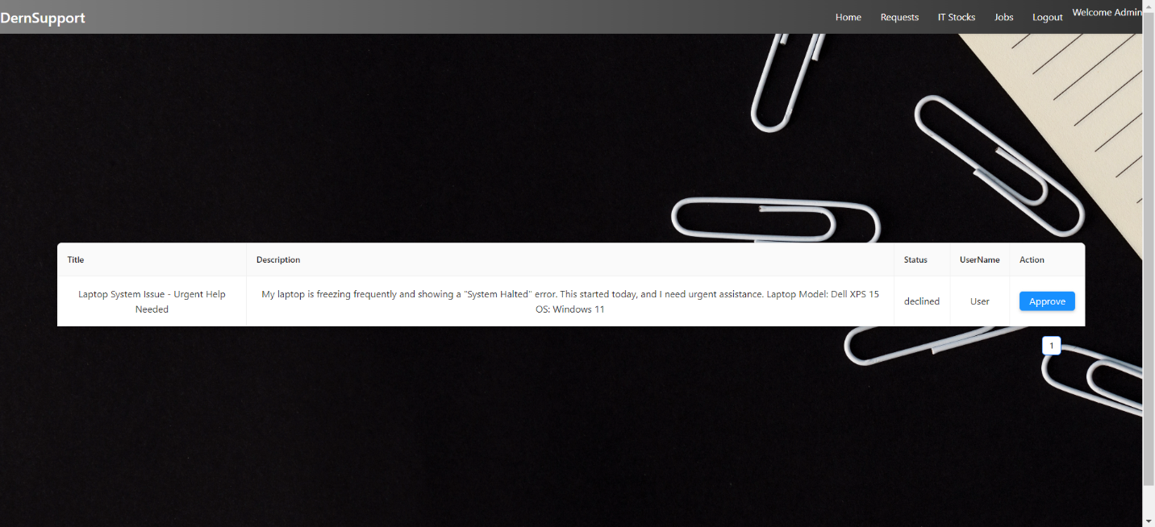

Figure 53 Admin Page Requests Declined Request 1

Admin Page Jobs:  
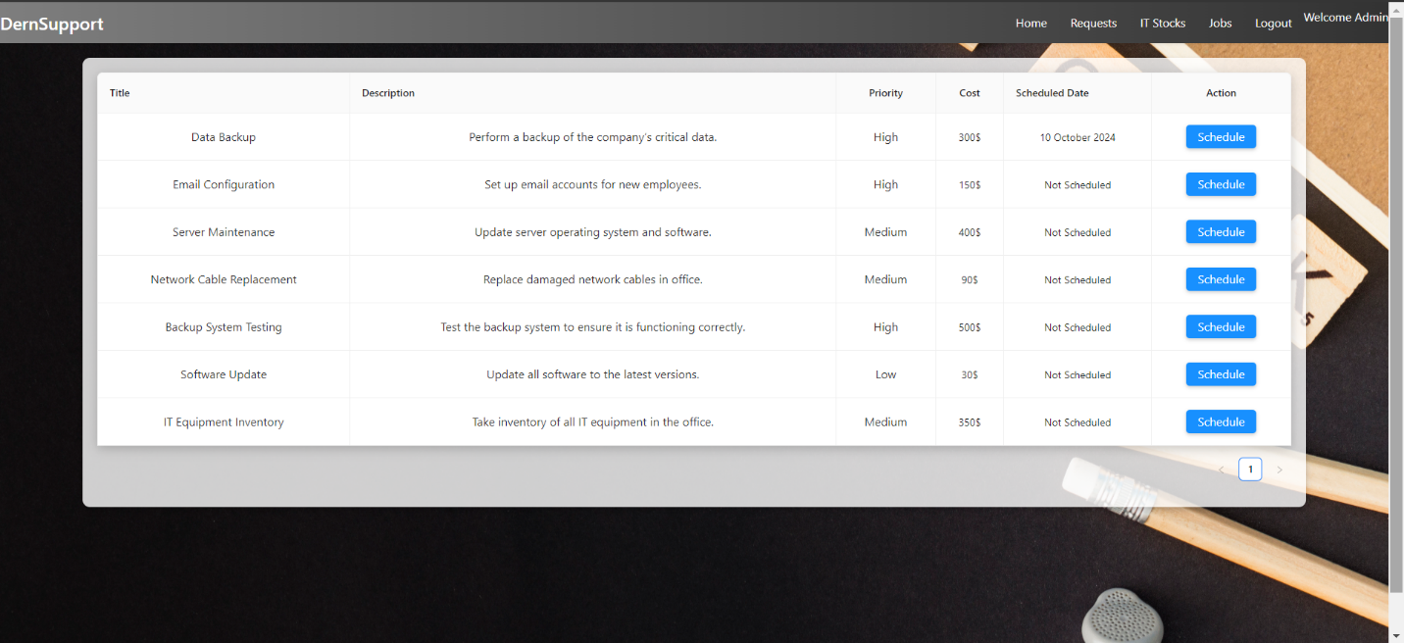

Figure 54 Admin Page Jobs 1

* **Observations:**
  + The "Declined Requests" section was accessible and displayed all declined requests with accurate details.
  + The "Approved Requests" section was accessible and displayed all approved requests with accurate details.
  + The "Jobs" page was accessible and displayed all job details correctly, including status and assigned technicians.

.

### Documenting Problems and Errors

#### Error 1: Slow Response Time

* **Issue:** Observed slow response time when submitting support requests during peak hours.
* **Resolution:** Performance optimization was carried out, including query optimization and load balancing.

#### Error 2: Inventory Sync Issue

* **Issue:** Initial delay in reflecting inventory updates in real-time.
* **Resolution:** Implemented real-time notifications for inventory changes to ensure immediate updates.

Admin Page IT Stocks Edited Stock Successful:



Figure 55 Admin Page IT Stocks Edited Stock Successful 2

#### Error 3: Registration with Existing Username

* **Issue:** Tried to register with an existing username and received a "Registration Failed" error.
* **Resolution:** Implemented a validation check to prevent users from registering with an already existing username. Now the system provides a clear error message indicating that the username is taken and prompts the user to choose a different one.

Try To Register With Username Exist:  
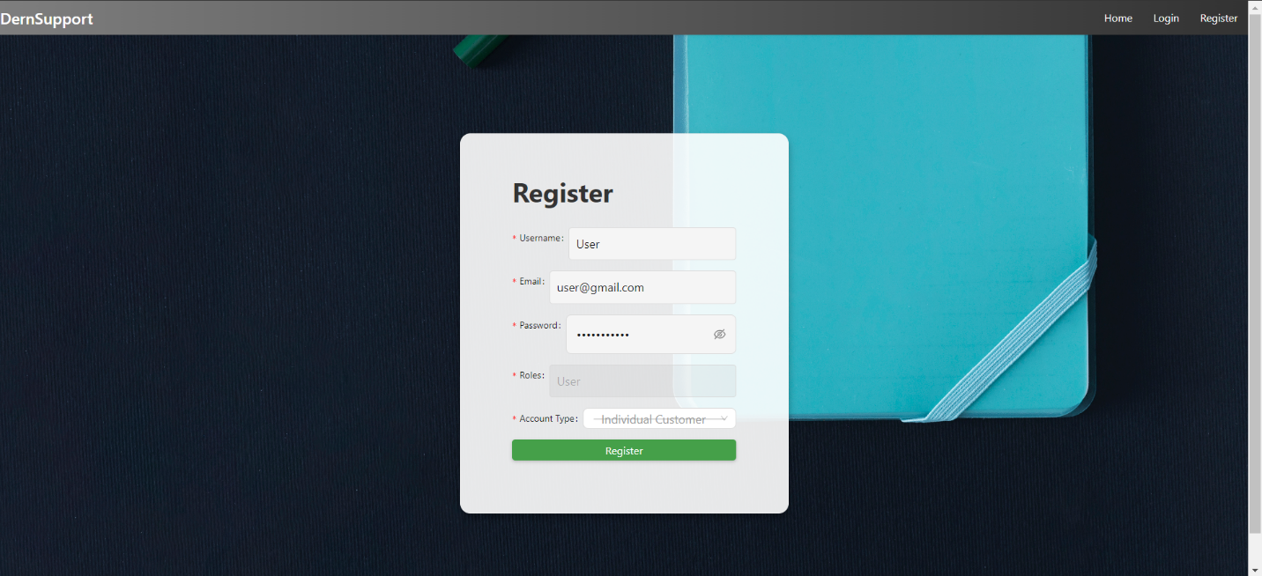

Figure 56 Try To Register With UserName Exist 1

Return Registration Failed:  
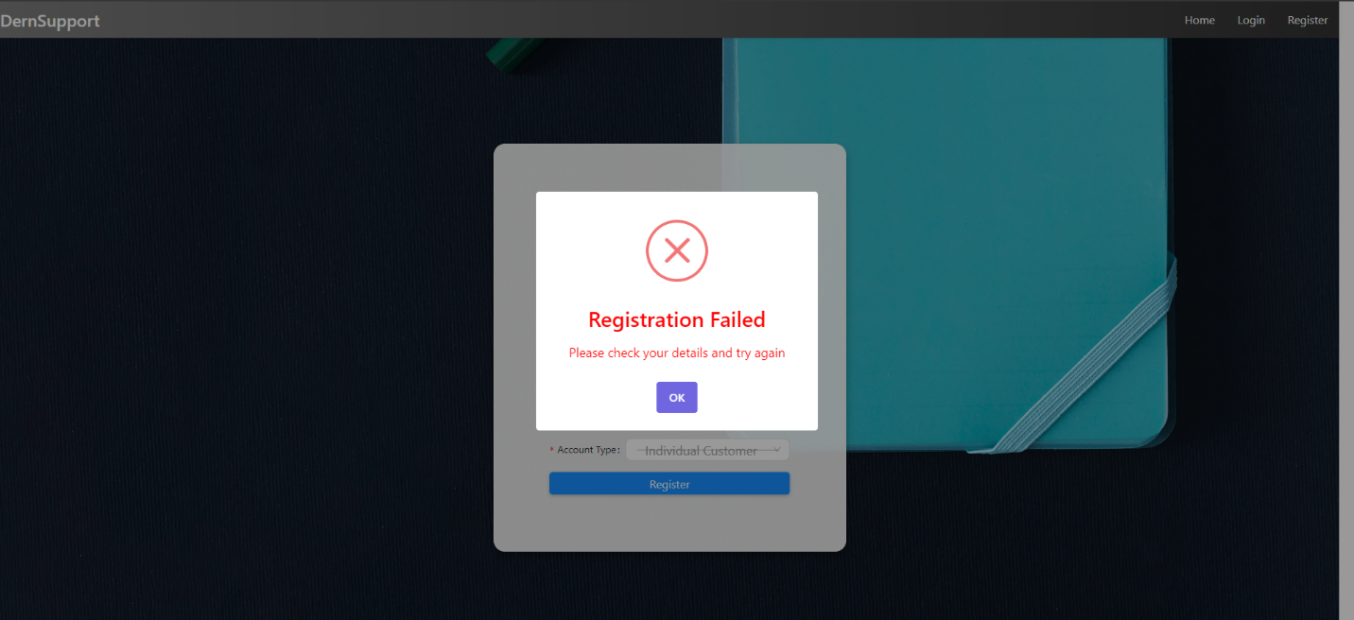

Figure 57 Return Registration Failed 1

#### Error 4: Registration with Invalid Password

* **Issue:** Tried to register with an invalid password (e.g., too short or missing special characters) and received a "Registration Failed" error.
* **Resolution:** Added password validation rules to ensure that passwords meet the security requirements (minimum length, special characters, etc.). The system now displays an appropriate error message guiding users to create a valid password.

Try To Register With Invalid Password:  
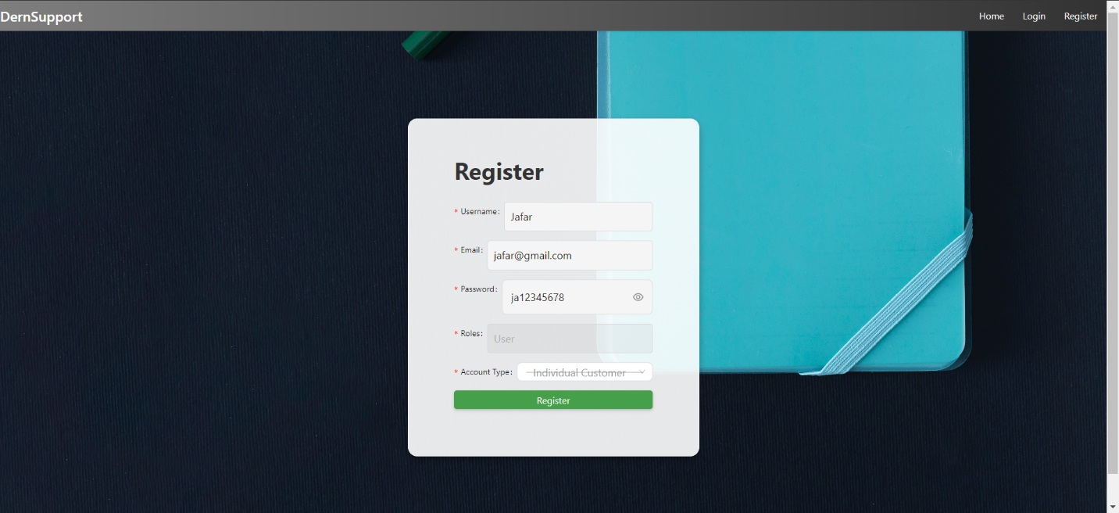

Figure 58 Try To Register With Invalid Password 1

Return Registration Failed:  


Figure 59 Return Registration Failed 2

#### Error 5: Invalid Login Attempt

* **Issue:** Tried to log in with an incorrect username or password, resulting in "Invalid Credentials."
* **Resolution:** Enhanced the login process to provide a clearer error message. Now, when invalid credentials are entered, the system immediately returns an "Invalid Credentials" error, prompting the user to try again or reset the password.

Try To Login With Invalid Username or Password:  
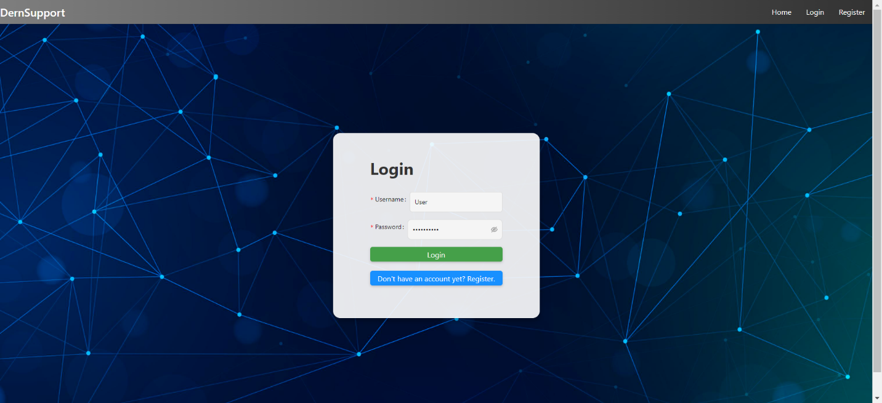

Figure 60 Try To Login With Invalid Username or Password 1

Return Invalid Credentials:  
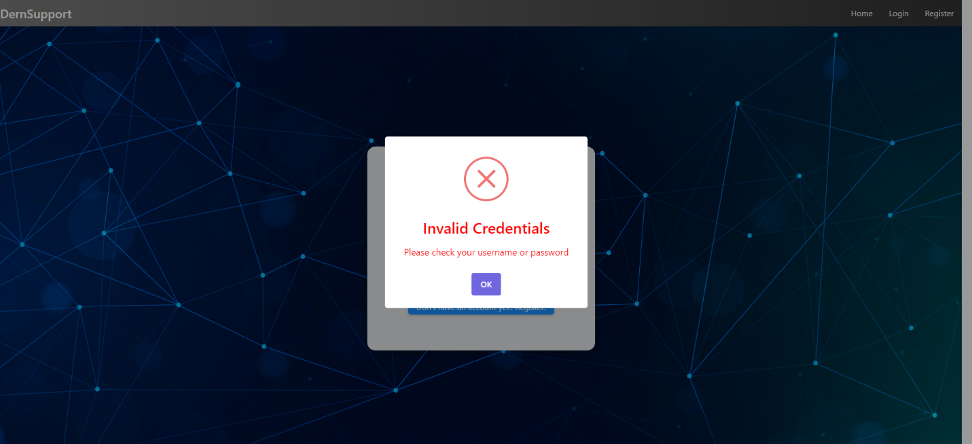

Figure 61 Return Invalid Credentials 1

#### Error 6: Submitting a Request Without Required Fields

* **Issue:** Tried to submit a support request without filling in all the required fields, resulting in "Submission Failed."
* **Resolution:** Added mandatory field validation. The system now prevents request submission until all required fields (title, description) are filled and highlights missing fields with error messages.

Try to SUBMIT A REQUEST Without Fill:  
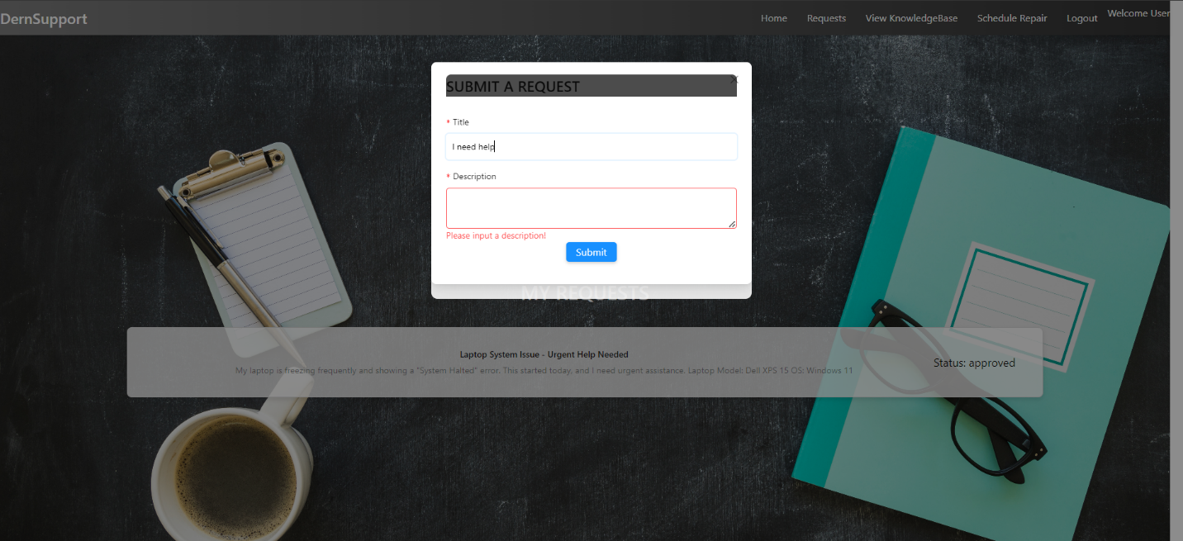

Figure 62 Try to SUBMIT A REQUEST Without Fill 1

Return Submission Failed:  
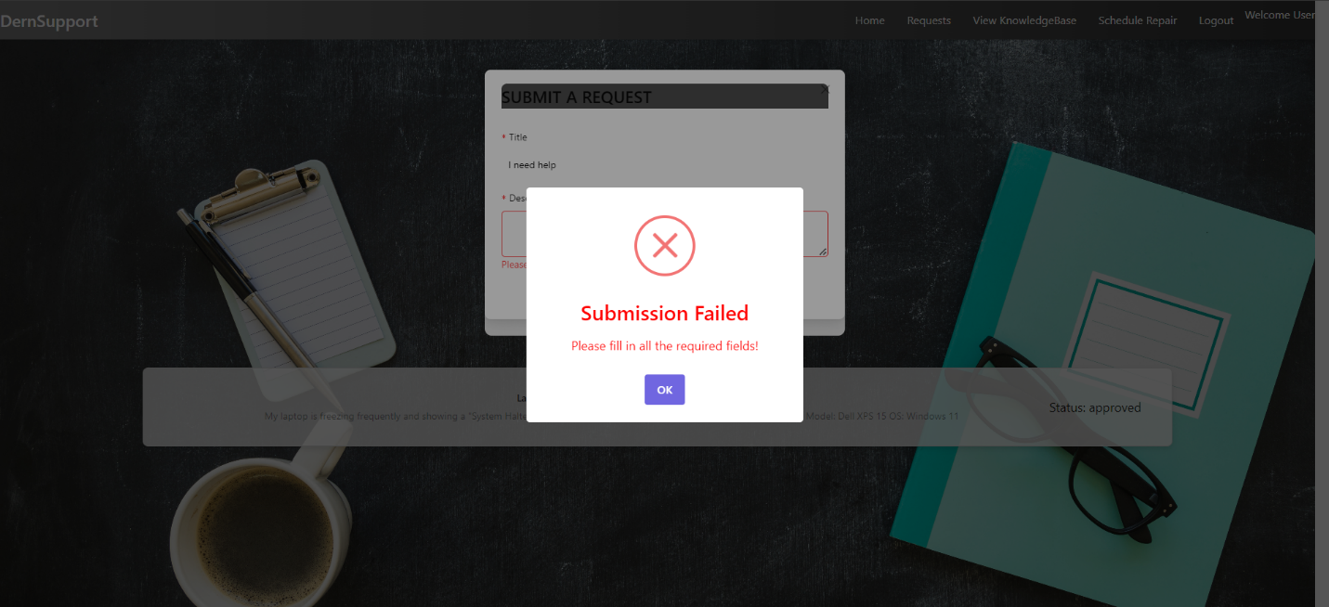

Figure 63 Return Submission Failed 1

#### Error 7: Scheduling a Repair with an Old Date

* **Issue:** The system allowed users to schedule repairs with dates in the past, resulting in scheduling conflicts.
* **Resolution:** Added a date validation check. Users can no longer schedule repairs for past dates, and an error message is shown when attempting to do so. The system now only allows future dates to be selected.

User Can Schedule Repair With Old Date:  
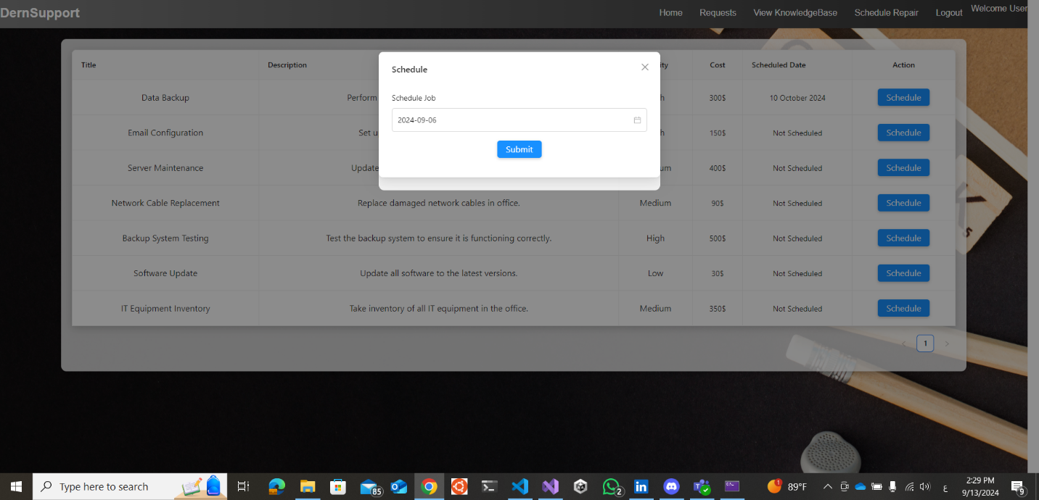

Figure 64 User Can Schedule Repair With Old Date 1

User Can't Schedule Repair With Old Date:  
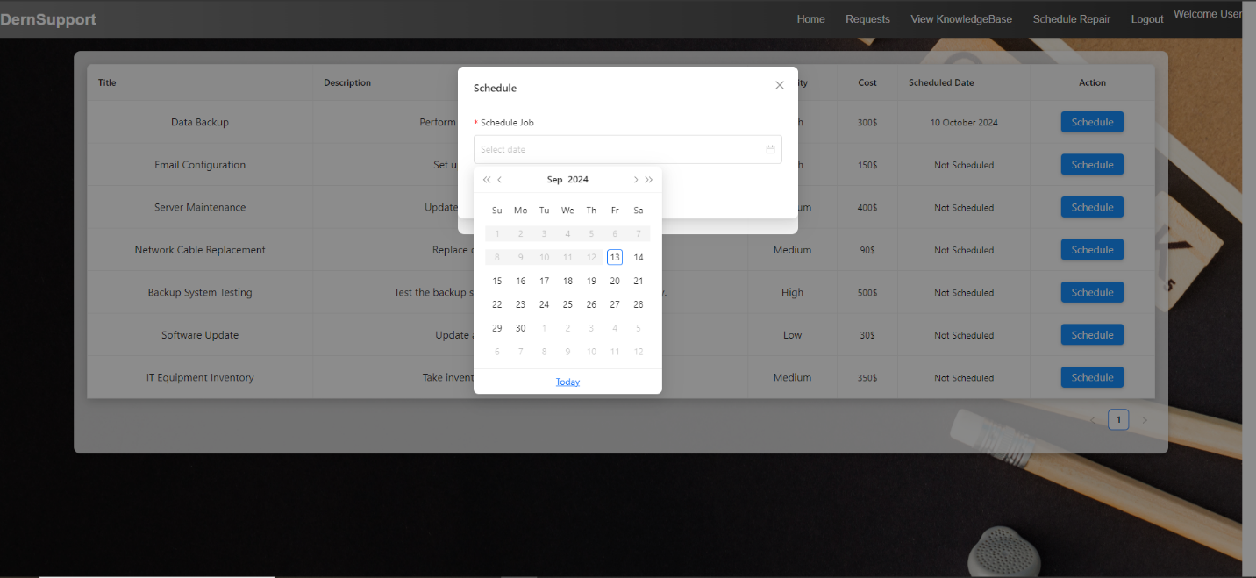

Figure 65 User Can't Schedule Repair With Old Date 1

### Feedback Analysis and Refinement

#### 2.1 Gathering Feedback

**Feedback Methods:**

* **User Testing Sessions:** Engaged users to interact with the system and provide feedback on its design and functionality.
* **Surveys:** Distributed post-testing surveys to gather opinions on usability, functionality, and design elements.

**Key Feedback Points:**

* **Usability:** Users appreciated the intuitive design but suggested additional search filters for inventory and a footer for easier navigation and access to important links.
* **Performance:** Some users experienced delays under heavy load.
* **Design:** Users recommended that the footer should include quick links to privacy policies, terms of service, contact information, and social media handles.
* **Features:** There was a request for a mobile-friendly design.

#### 2.2 Refining the Solution

**Refinement Actions:**

* **Enhanced Navigation:** Added additional filters for inventory searches based on user feedback to improve search functionality.
* **Footer Implementation:** A footer was designed and added to the website, incorporating:
  + Quick links to important sections like privacy policies, terms of service, and FAQs.
  + Contact information for easier communication.
  + Social media links for broader engagement and accessibility.
* **Performance Improvements:** Optimized system performance to handle higher loads effectively.
* **Mobile Compatibility:** Initiated development of a mobile-friendly interface to meet user requests.

Page IT Stocks Search:  


Figure 66 Page IT Stocks Search 1

Footer:  
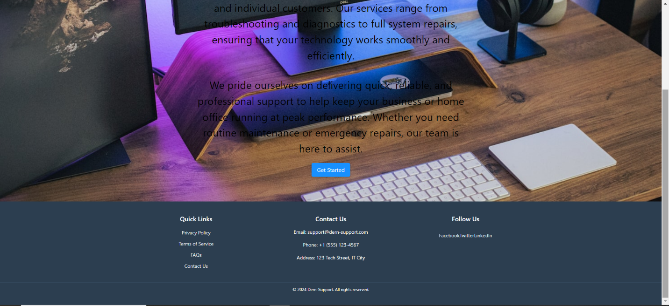

Figure 67 Footer 1

### Evaluation of the Solution

#### Efficiency

* **Performance:** Achieved response times under the required 2 seconds for most operations.
* **Resource Utilization:** Efficient database usage with optimized queries and real-time updates.

DernSupportDB:  
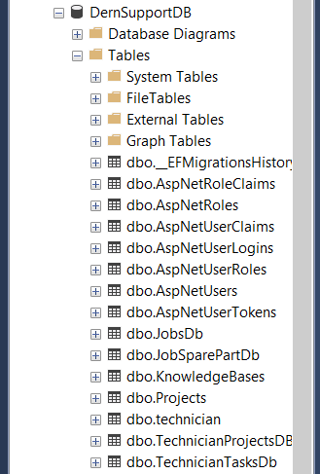

Figure 68 DernSupportDB 1

AspNetUsers Table:  
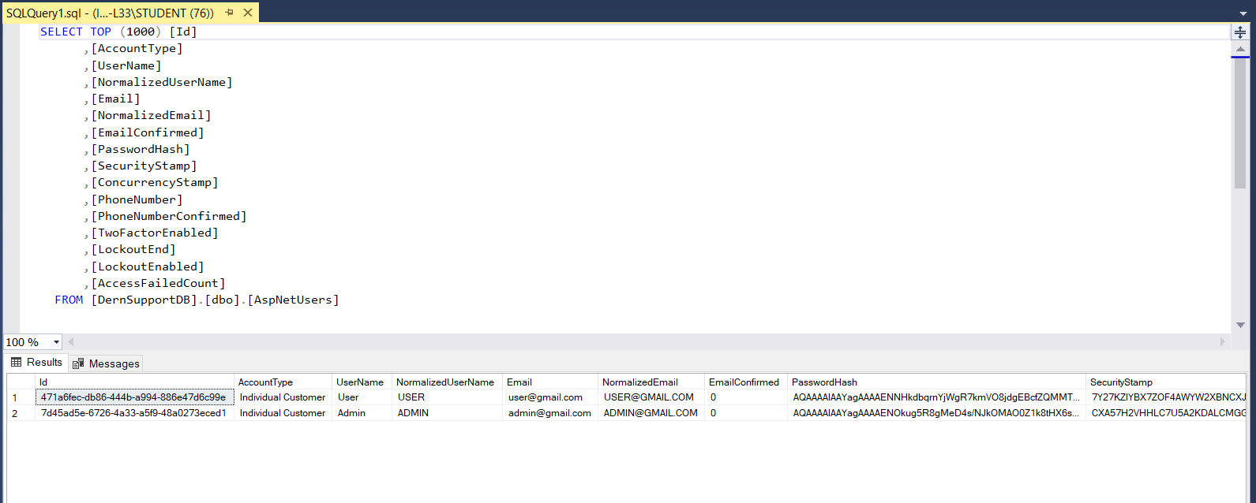

Figure 69 AspNetUsers Table 1

AspNetRoles Table:  
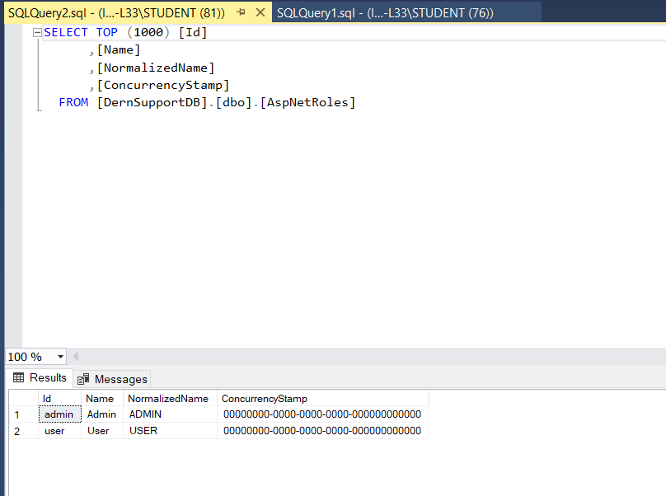

Figure 70 AspNetRoles Table 1

JobsDb Table:  
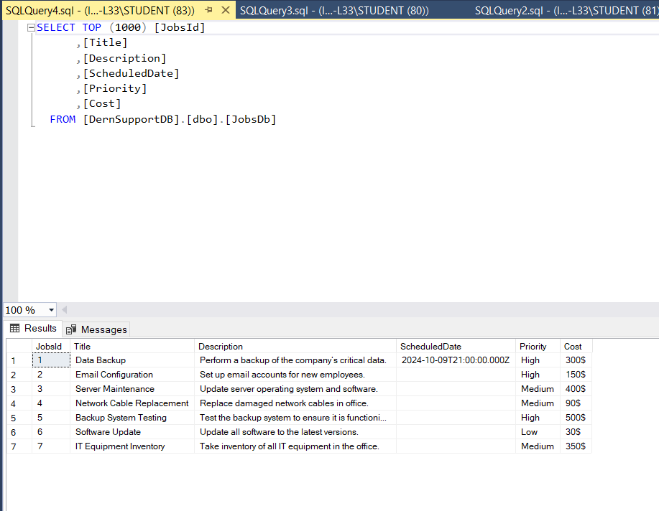

Figure 71 JobsDb Table 1

JobSparePartDb Table:  
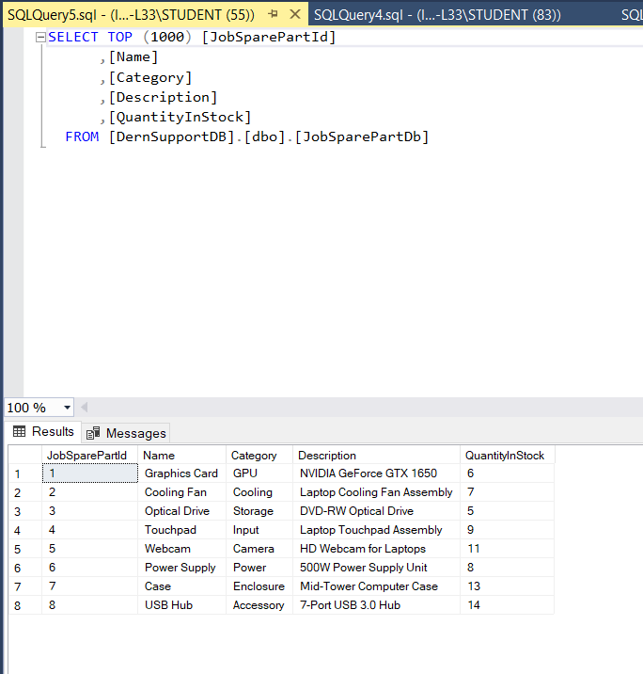

Figure 72 JobSparePartDb Table 1

KnowledgeBases Table:  
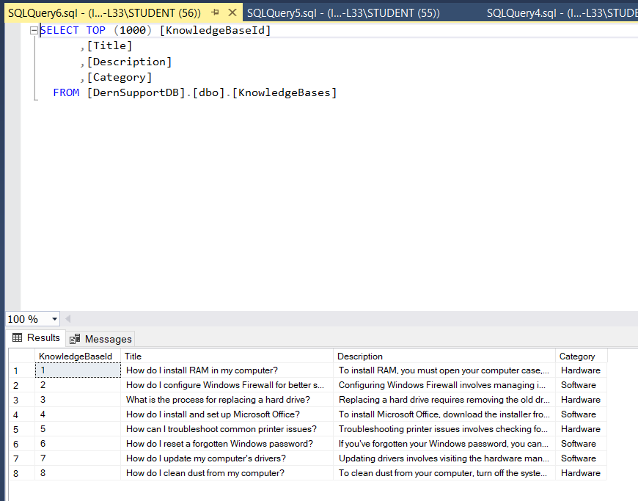

Figure 73 KnowledgeBases Table 1

Projects Table:  
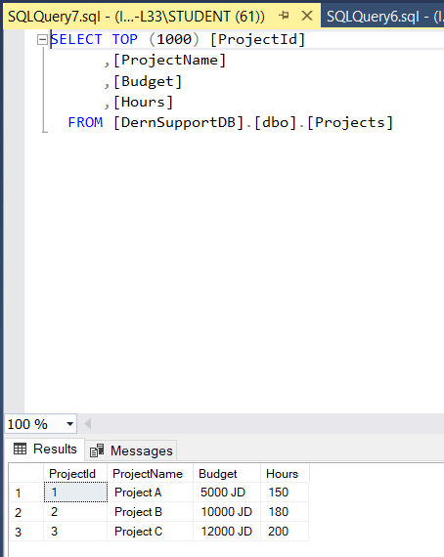

Figure 74 Projects Table 1

Technician Table:  
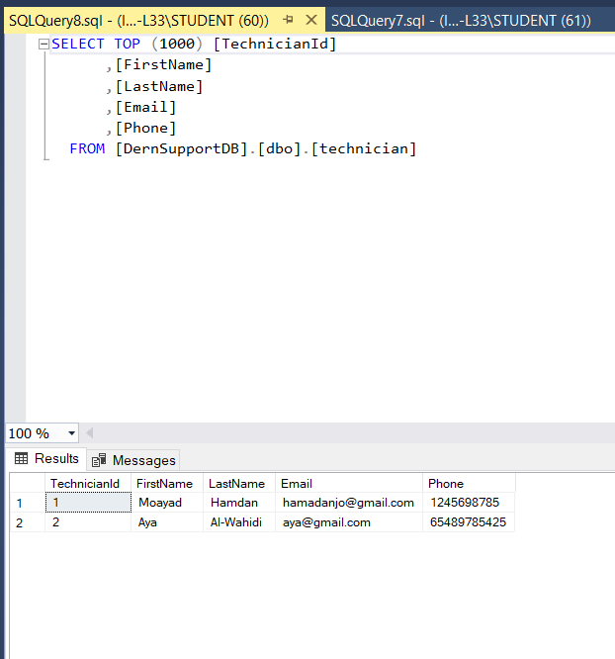

Figure 75 Technician Table 1

TechnicianProjectsDBset Table:  
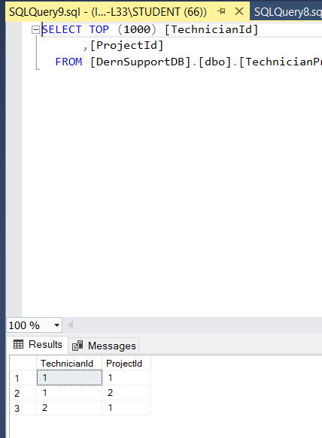

Figure 76 TechnicianProjectsDBset Table 1

TechnicianTasksDb Table:  
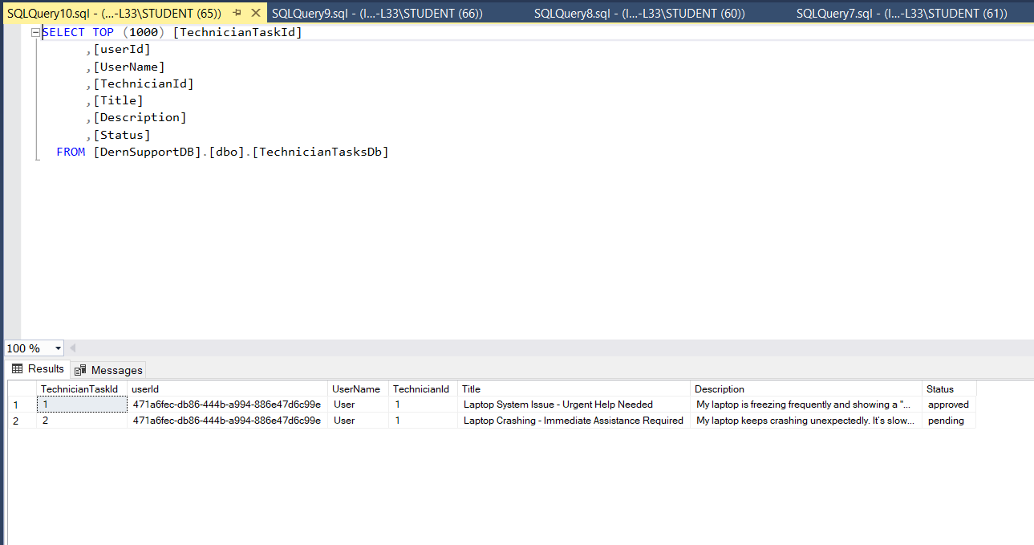

Figure 77 TechnicianTasksDb Table 1

#### Effectiveness

* **Problem Resolution:** The system effectively addresses key challenges, including support request management and inventory tracking.
* **User Feedback:** Generally positive, with identified areas for improvement addressed in the refinement phase.

#### Requirement Fulfillment

* **Customer Account Management:** Both individual and business accounts are functioning as required.
* **Support Request Handling:** Submissions, tracking, and history are managed effectively.
* **Inventory Management:** Real-time tracking and alerts are operational.
* **Job Scheduling:** Scheduling and prioritization are implemented successfully.

#### Future Development Suggestions

* **Automation:** Explore options for automated inventory reordering based on usage patterns.
* **Advanced Analytics:** Integrate predictive analytics for improved forecasting of potential issues.
* **Mobile Support:** Complete development of the mobile-friendly interface for broader accessibility.

# Conclusion

# Summary of the Project’s Achievements:

The Dern-Support project successfully addressed key challenges in customer support management by implementing a comprehensive full-stack solution that streamlined operations and enhanced the overall user experience. Major achievements include:

1. **Enhanced Ticket Management:** The project introduced a centralized ticket management system that allowed support staff to efficiently track, prioritize, and resolve customer issues, reducing response times and improving service quality.
2. **Robust Reporting and Analytics:** A new dashboard with reporting capabilities provided valuable insights into support operations, enabling data-driven decisions and performance monitoring.
3. **User-Friendly Interface:** The implementation of a responsive and intuitive user interface improved the experience for both customers and support staff, making the platform accessible and easy to navigate.
4. **Knowledge Base Implementation:** The addition of a self-service knowledge base empowered customers to find solutions independently, reducing the workload on support staff and enhancing customer satisfaction.

# Lessons Learned:

1. **Importance of User Feedback:** Regular feedback from end-users (both support staff and customers) proved crucial in identifying pain points and areas needing improvement during the development process.
2. **Scalability Considerations:** Ensuring the system was designed to handle increased ticket volumes and additional features highlighted the need to prioritize scalable architecture from the outset.
3. **Integration Challenges:** Integrating the new system with existing legacy tools was more complex than anticipated, emphasizing the need for thorough planning and testing during the integration phase.
4. **Emphasis on Automation:** Automating repetitive tasks, such as notifications and ticket assignments, significantly reduced manual workload and improved efficiency, underlining the value of automation in support systems.

# Recommendations for Future Improvements:

1. **Expand Automation Capabilities:** Future updates should focus on further automating repetitive support tasks, such as AI-driven ticket classification and response suggestions, to enhance efficiency.
2. **Enhance Analytics and Reporting:** Expanding analytics features to include more advanced data visualization and predictive insights can help support teams identify trends and proactively address common issues.
3. **Mobile App Development:** Developing a dedicated mobile app for Dern-Support could offer customers and support staff greater flexibility and accessibility, further enhancing the user experience.
4. **Ongoing Training and Support:** Continuous training for support staff on system updates and best practices will ensure the platform is utilized to its full potential and support quality remains high.
5. **Regular Updates to the Knowledge Base:** Keeping the knowledge base up to date with the latest information and solutions will maintain its effectiveness as a self-service tool for customers.